A l p h a l i z e T e c h n o l o g i e s

369 Attendance

Administrator Guide
Set the rules, keep the approvals moving, and close the month's payroll.

About This Guide
This is the guide for the person who runs 369 Attendance for the company: the one who sets office hours and holidays, decides the leave policy, keeps the approval queues clear, and closes each month's payroll.
Everything in it happens on the phone, in the Config tab and the screens it opens. Every button name, field label and message is quoted from the app itself, so what you read here is what you will see on the screen. Where the app's own wording names the back office, this guide says the web console instead.
The Config tab shows only the sections your rights allow. If a section in this guide is missing from your menu, your login does not carry that right; users and their permissions are set up on the web console, not in the app.
Your own check-ins, leave and work-from-home requests work exactly as they do for everyone else, and are described in the Employee Guide. The approval screens you share with HR are described here in brief and in full in the HR Guide.
TIP Every admin screen opens with a yellow guide box that lists its steps. Tap the guide's title to fold it away for this visit; it comes back the next time you open the screen.

369 Attendance at a Glance
▪ Every morning — open Config and clear whatever carries a red badge: absentees, pending leave, pending work from home, draft payroll runs.
▪ Once, at setup — set Office Hours & Working Days, the day status ladder, Public Holidays and the Leave Policy.
▪ As requests arrive — approve or reject leave and work from home, and decide cancellations of approved leave.
▪ As people work days off — check Compensatory Off credits, and add one by hand when the system missed a day.
▪ At month end — create the payroll run, generate the payslips, confirm, and mark it paid; generate the month's report.

PART 1 THE CONFIG TAB

Step 1 Find the Config Tab
Along the bottom of the app sit three tabs: Home, Config and Profile. Config is the middle one, and it is only there for administrators.
It appears a moment after you sign in, once the server has confirmed what you are allowed to change. Somebody with HR rights but no administrator rights gets a smaller HR tab in the same place instead, holding today's attendance and the approval queues and no configuration at all.
The tab opens on a dark header reading Config and Administration, with the Admin menu guide beneath it: Each row opens one admin screen, and every screen starts with a yellow guide like this one. A red badge shows how many items are waiting for you. This full menu is for admins; HR users get the simpler HR tab instead.
What you tap | What happens
Home | Your own attendance, leave and work from home
Config | The admin menu described in this guide
Profile | Your own My details

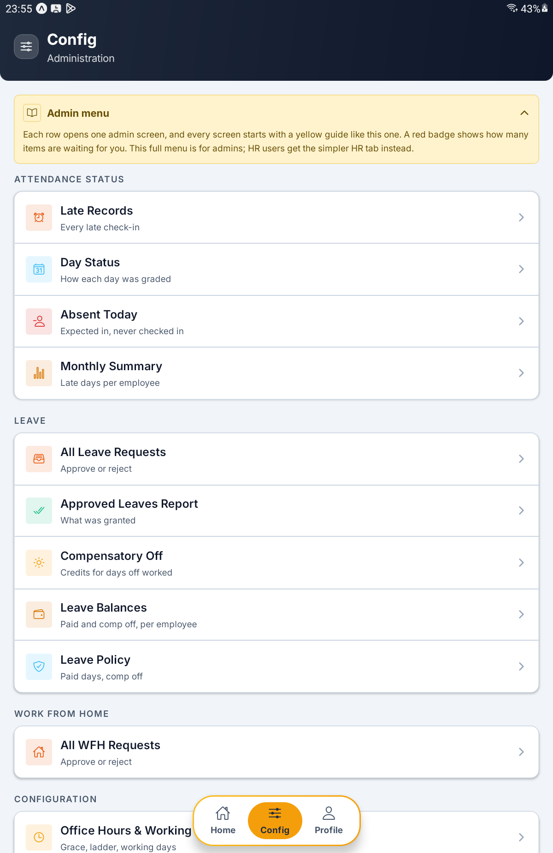
The Config tab — the Admin menu guide and the Attendance status and Leave sections

Step 2 Read the Admin Menu
The menu is grouped into sections, each with a heading in small capitals and a card of rows. Every row carries an icon, a name and a one-line caption, and opens one screen.
Each section is shown only when your login holds the right behind it, so two administrators can see different menus.
Section | What lives in it
ATTENDANCE STATUS | Late Records, Day Status, Absent Today, Monthly Summary
LEAVE | All Leave Requests, Approved Leaves Report, Compensatory Off, Leave Balances, Leave Policy
WORK FROM HOME | All WFH Requests
CONFIGURATION | Office Hours & Working Days, Public Holidays, Auto-Approval
EMPLOYEE DETAILS | Field Settings, Salary Components, Statutory ID Types
PAYROLL | Payroll Runs, Payslips
REPORTS | Generate Report, Past Reports

If you manage attendance but not leave, the LEAVE section is replaced by a shorter LEAVE BALANCES section holding just Compensatory Off and Leave Balances.
Four rows carry a red badge when something is waiting, and the numbers are fetched again every time you come back to the tab.
Badge on | What it counts
Absent Today | People marked absent today
All Leave Requests | Leave requests still pending
All WFH Requests | Work-from-home requests still pending
Payroll Runs | Payroll runs still in draft

A row with nothing waiting carries no badge at all, rather than a grey zero.
TIP If the header reads Nothing assigned to you and the card says Checking what you can administer…, the app is still asking the server about your rights. It clears on its own a moment later.

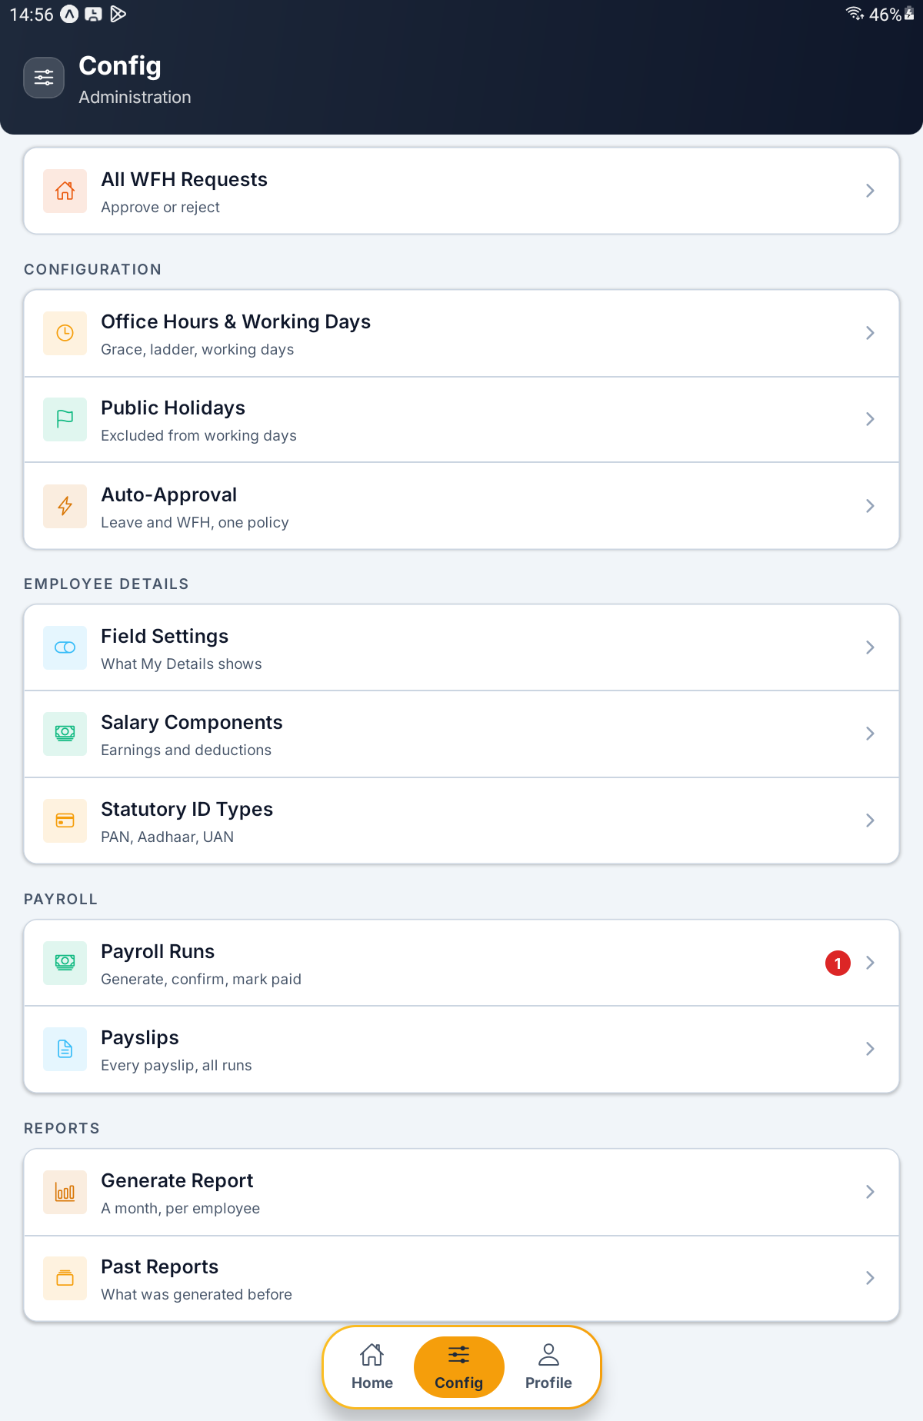
The lower half of the menu — Configuration, Employee details, Payroll with a draft-run badge, and Reports

Step 3 Move Around the Admin Screens
Every screen the menu opens works the same way. A back chevron sits top left in the dark header, with the screen's name and a caption beside it. The yellow guide comes first, then the content.
What you see | What it does
Back chevron | Returns to the menu
Arrows either side of a month or year | Page backwards and forwards; on most monthly screens the forward arrow stops at the current month
Chips under the header | Filter the list, such as Pending or All
Pull down on a list | Refreshes it from the server
Retry under a red message | Tries again after the server could not be reached

These screens cover the tab bar while they are open. Use the back chevron, or the phone's back button, to return to Config.

PART 2 ATTENDANCE STATUS

Step 4 Look Through the Late Records
Tap Late Records (Every late check-in). The header shows a month with an arrow either side.
Each row is one late check-in: the person's name, the date, the time in and the time out (or still in), and an amber chip with how many minutes late they were. A line above the list totals the month, for example 3 late check-ins · 0h 45m total.
An empty month says Nobody was late, and suggests checking that late tracking is on for the scope in Office Hours.
What you see | What it means
The minutes chip | How late, counted from office start
still in | They have not checked out yet
The total line | Every late check-in in the month, and the late time added up

IMPORTANT Being late costs nothing. The only pay cut on this side of the app is a Half Day, set by the day status ladder in PART 7.

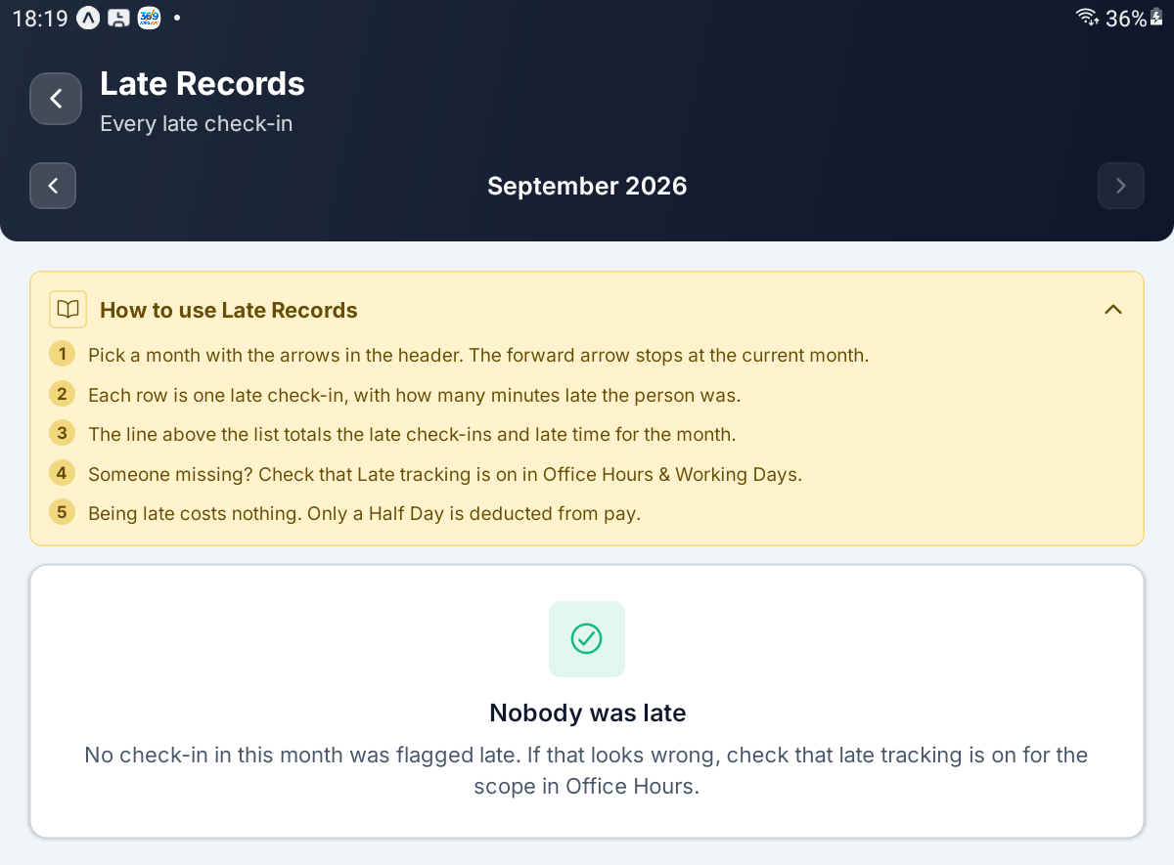
Late Records — the month arrows, the guide and an empty month

Step 5 See How Each Day Was Graded
Tap Day Status (How each day was graded) and pick a month.
A row of tiles counts how many days got each label. Tap a tile to show only those days, and tap it again, or Show all, to clear the filter.
Each row is one employee on one day, with a coloured label chip. Small chips add WFH or On leave where they apply, and auto-stamped marks a row the server wrote by itself. A red figure beneath the label is that day's deduction.
Label | What it means
Present | In on time, or arrived after the late window closed
Late | In after office start plus grace; recorded, never charged
Half Day | Arrived after Half day after, or worked less than the Half day below ratio; half a day's pay is cut
Leave | Covered by approved leave
Absent | Never checked in on a working day
Day Off | A weekly off or holiday that was worked; never deducted, and earns comp off

IMPORTANT Rows appear as people check in. Absent rows are stamped automatically only once the office passes Late window ends, and that time ships switched off. Until you set it in Office Hours, nobody is ever marked Absent and this screen can stay empty.

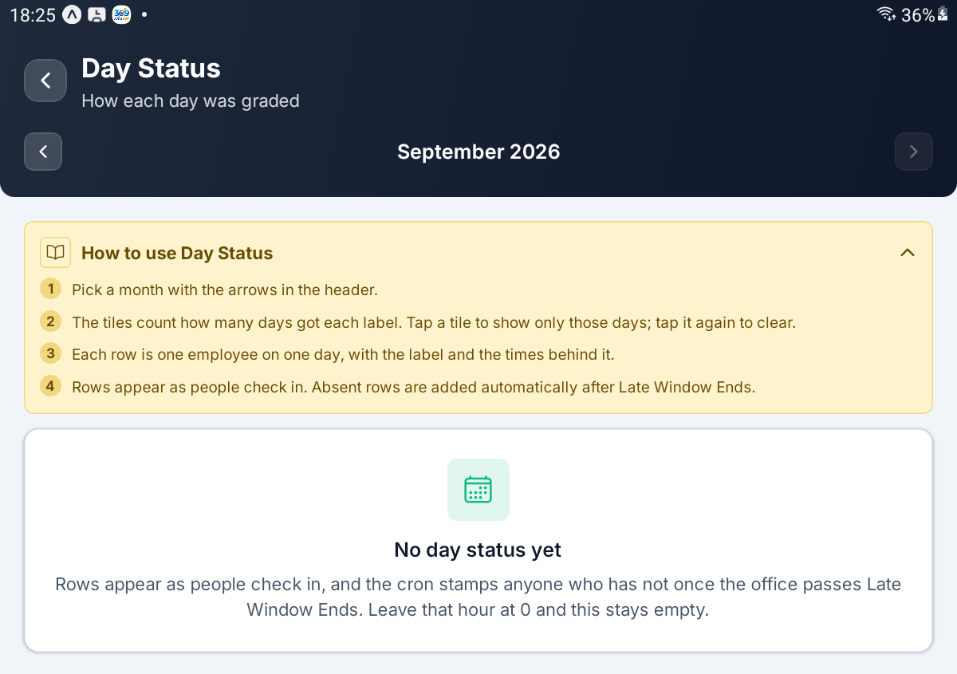
Day Status — an empty month, explaining that absentees wait for Late Window Ends

Step 6 Check Who Is Absent Today
Tap Absent Today (Expected in, never checked in). The header shows today's date; there is no month picker, and pulling down refreshes the list.
A line reads, for example, 2 people have not checked in., and each row names one person with their Absent label. People on approved leave or an approved work-from-home day are never listed here. An empty list says Nobody is absent today.
What you see | What to do
A name on the list | Check All Leave Requests or All WFH Requests for a request still waiting
An empty list early in the day | Normal — absentees are only marked once the late window ends

TIP This list is built from the same automatic stamping as Day Status. With Late window ends left at 00:00 it stays empty however many people are missing.

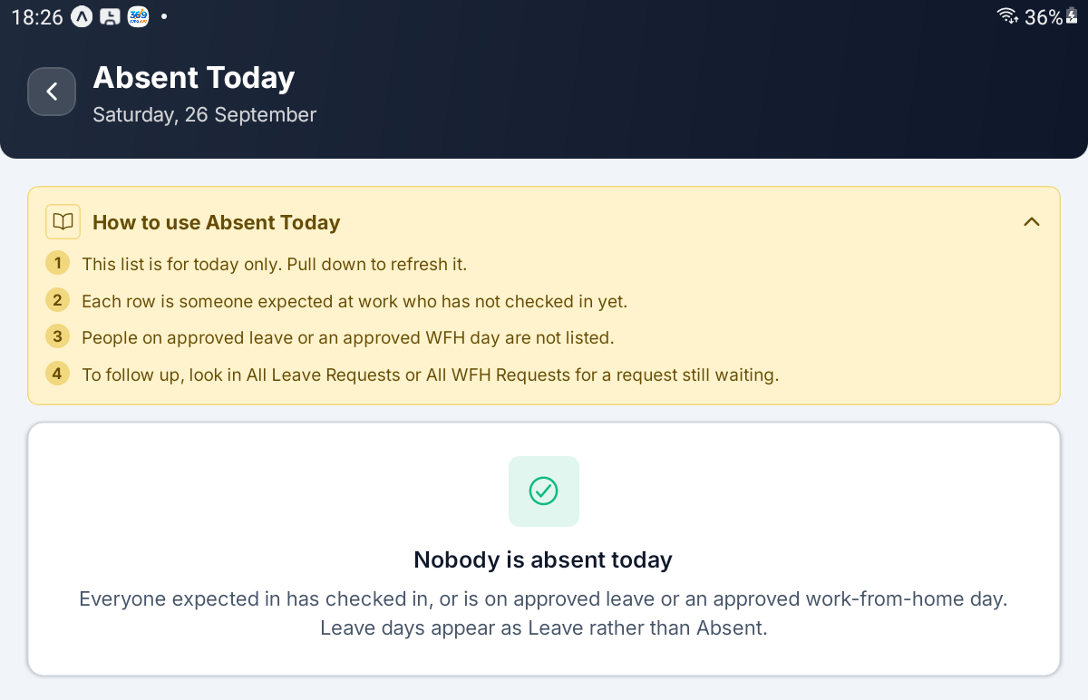
Absent Today — the date in the header and the Nobody is absent today card

Step 7 Generate the Monthly Summary
Tap Monthly Summary (Late days per employee). This screen builds a ranking rather than showing a list.
Choose the Month, type the Year, and optionally pick a Department (the default is All departments). Tap Generate.
The result ranks everyone by late days, each row showing their department, the number of days in the form 3d, and the total late time. Two chips at the top count the employees and the late days. Tap Change month to go back to the picker.
Field | What it controls
Month | The month to count
Year | Four digits; anything else gives Give a four-digit year.
Department | One department, or All departments

An empty result reads No chargeable late days. Arrivals after Late window ends, and any check-in that is not the day's first, are deliberately left out of the count.
IMPORTANT Generating replaces the previous summary for everyone, including the copy on the web console. Two people generating at the same time overwrite each other.

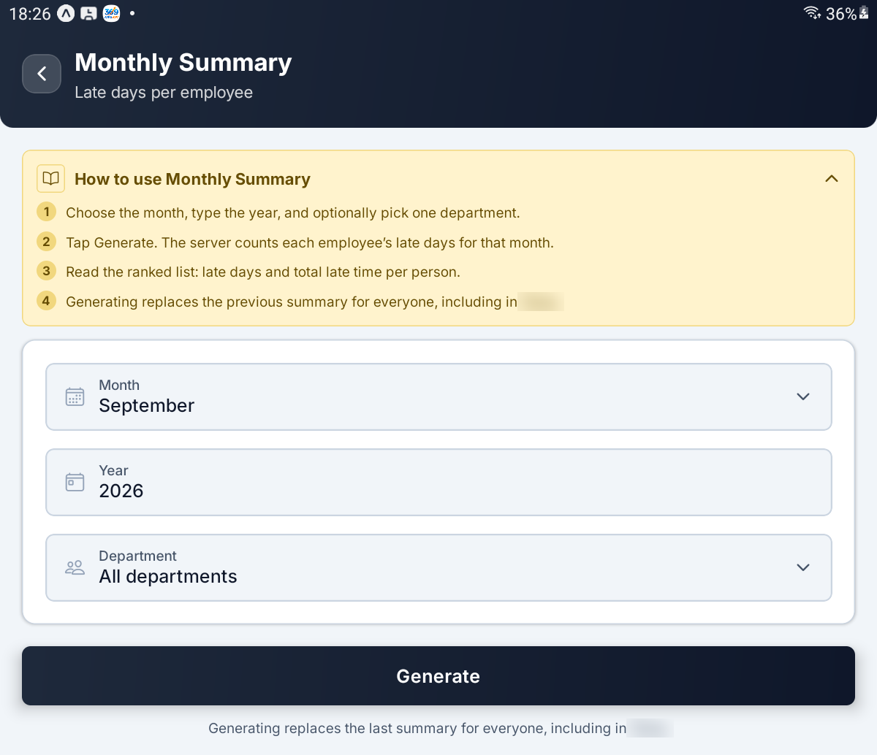
Monthly Summary — Month, Year, Department and the Generate button

PART 3 LEAVE REQUESTS

Step 8 Work the Leave Queue
Tap All Leave Requests (Approve or reject). It opens on Pending — the requests waiting for a decision — with a count such as 2 requests above the cards.
Each card shows who asked, the leave type and length (for example Casual · 2 days or Comp Off · half day), the dates, and a status chip. Cancel asked means an approved leave the employee now wants to cancel, and auto means the server approved it without anyone looking.
Chip | What it shows
Pending | Waiting for a decision
Cancellation | Approved leave the employee has asked to cancel
All | Everything, whatever its state
Approved | Granted
Rejected | Turned down

The list reloads every time you come back to it, so a decision you have just made shows straight away. An empty Pending list says Nothing waiting.
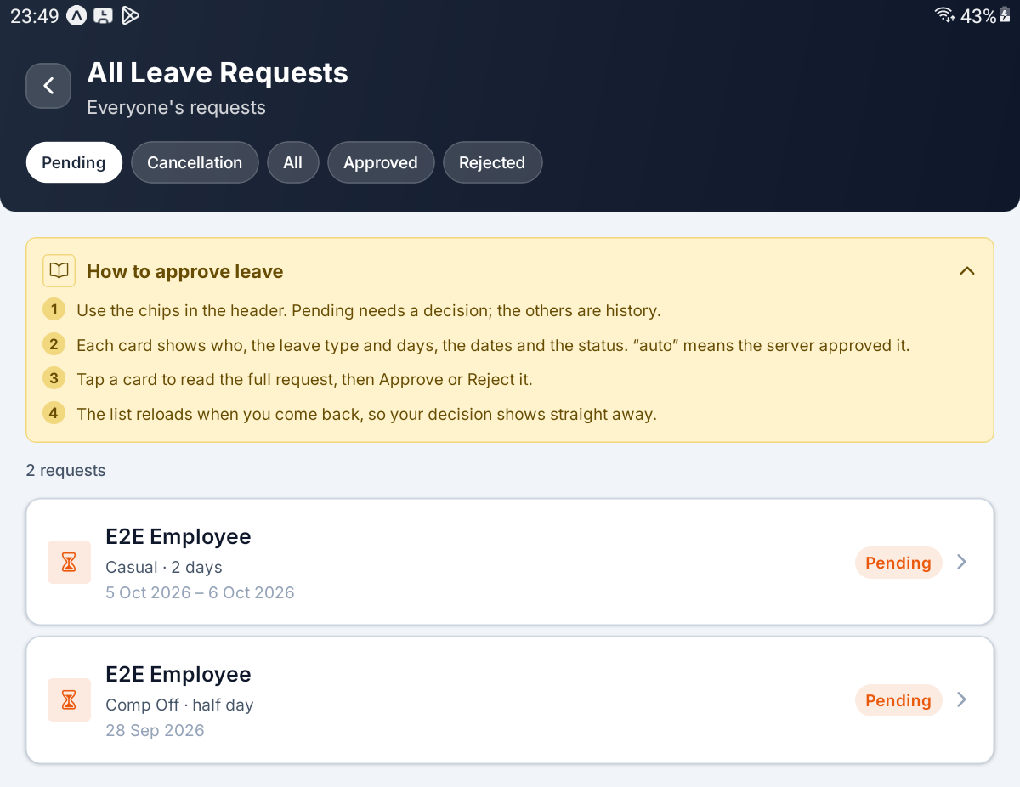
All Leave Requests — the filter chips and two pending requests

Step 9 Approve or Reject a Leave Request
Tap a card. The request opens with the leave type and status, then Dates, Days, Paid / unpaid, and Submitted. A comp-off request also shows Earned on and Comp-off balance, which turns red if the balance is smaller than the request. Where the request costs money, Deduction appears in red. The employee's reason sits beneath under REASON.
Paid / unpaid is the figure to read first: it shows how many of the days the policy will pay and how many will not.
What you tap | What happens
Approve | Asks Approve this request? — the person will be marked on leave, and those days leave the attendance grading. Confirm with Approve
Reject | Asks Reject this request? and for a Reason for rejection. The reason is required, and the employee sees it

You will see Request approved. or Request rejected. and be returned to the queue.
Only a pending request can be decided. A request already decided shows, for example, Already rejected — only a pending request can be decided. If another manager got there first, the server's refusal is shown to you as it stands.
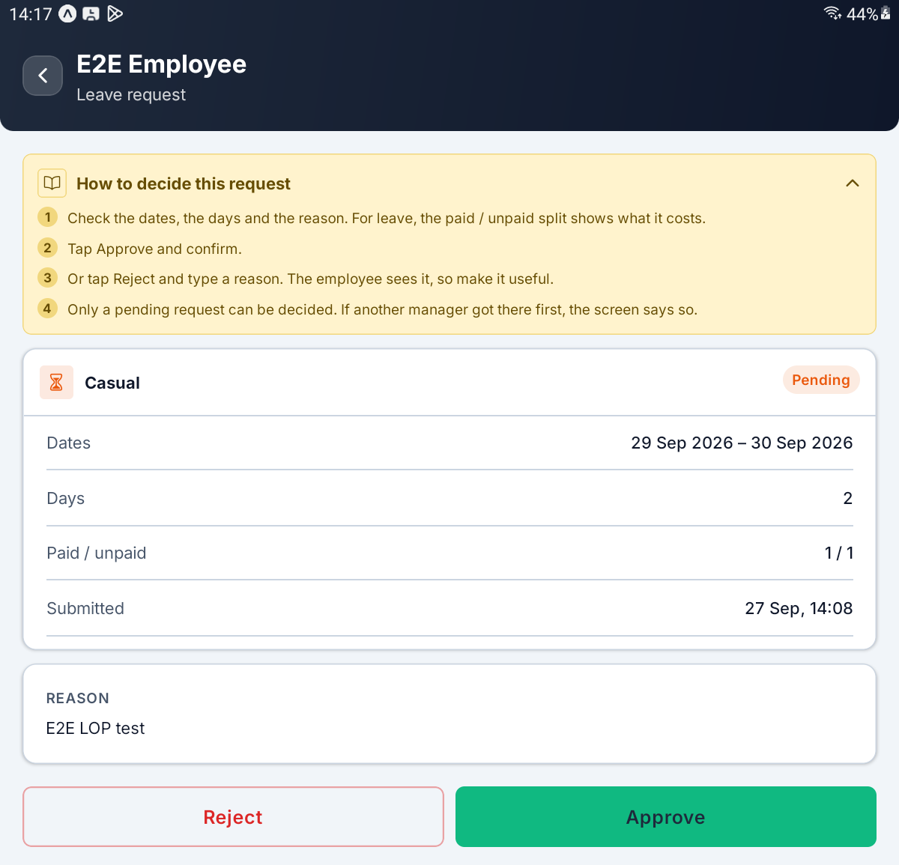
A pending leave request — Dates, Days, Paid / unpaid, the reason, and Reject and Approve

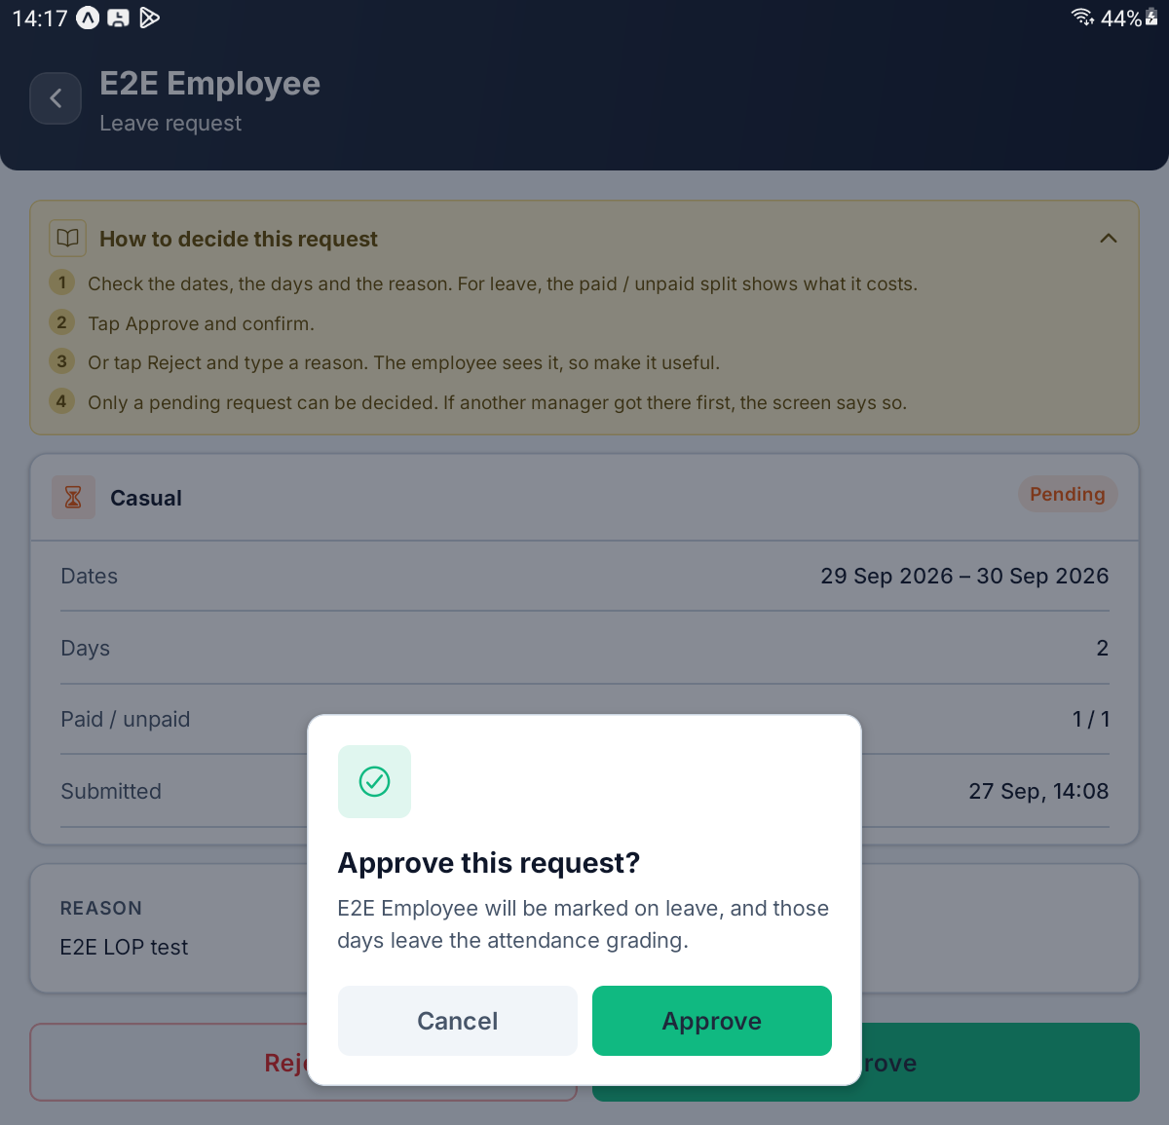
The Approve this request? confirmation

Step 10 Decide a Cancellation, or Cancel Approved Leave Yourself
An approved leave the employee wants to cancel shows an orange CANCELLATION REQUESTED box with their reason and when they asked. Two buttons replace Approve and Reject.
What you tap | What happens
Approve cancellation | Asks Approve the cancellation? The leave is cancelled and its days go back to the balance. You see Leave cancelled.
Keep leave | Asks Keep this leave? and for Why it stays. The leave stays approved and the employee sees your reason. You see Cancellation declined; leave kept.

An approved leave with no cancellation request shows a single Cancel this leave button instead. It asks Cancel this approved leave?, and Cancel leave confirms it; Back leaves it alone.
IMPORTANT Cancelling approved leave is refused once that month's payroll is confirmed or paid. A confirmed run can be put Back to draft first; a paid run cannot.

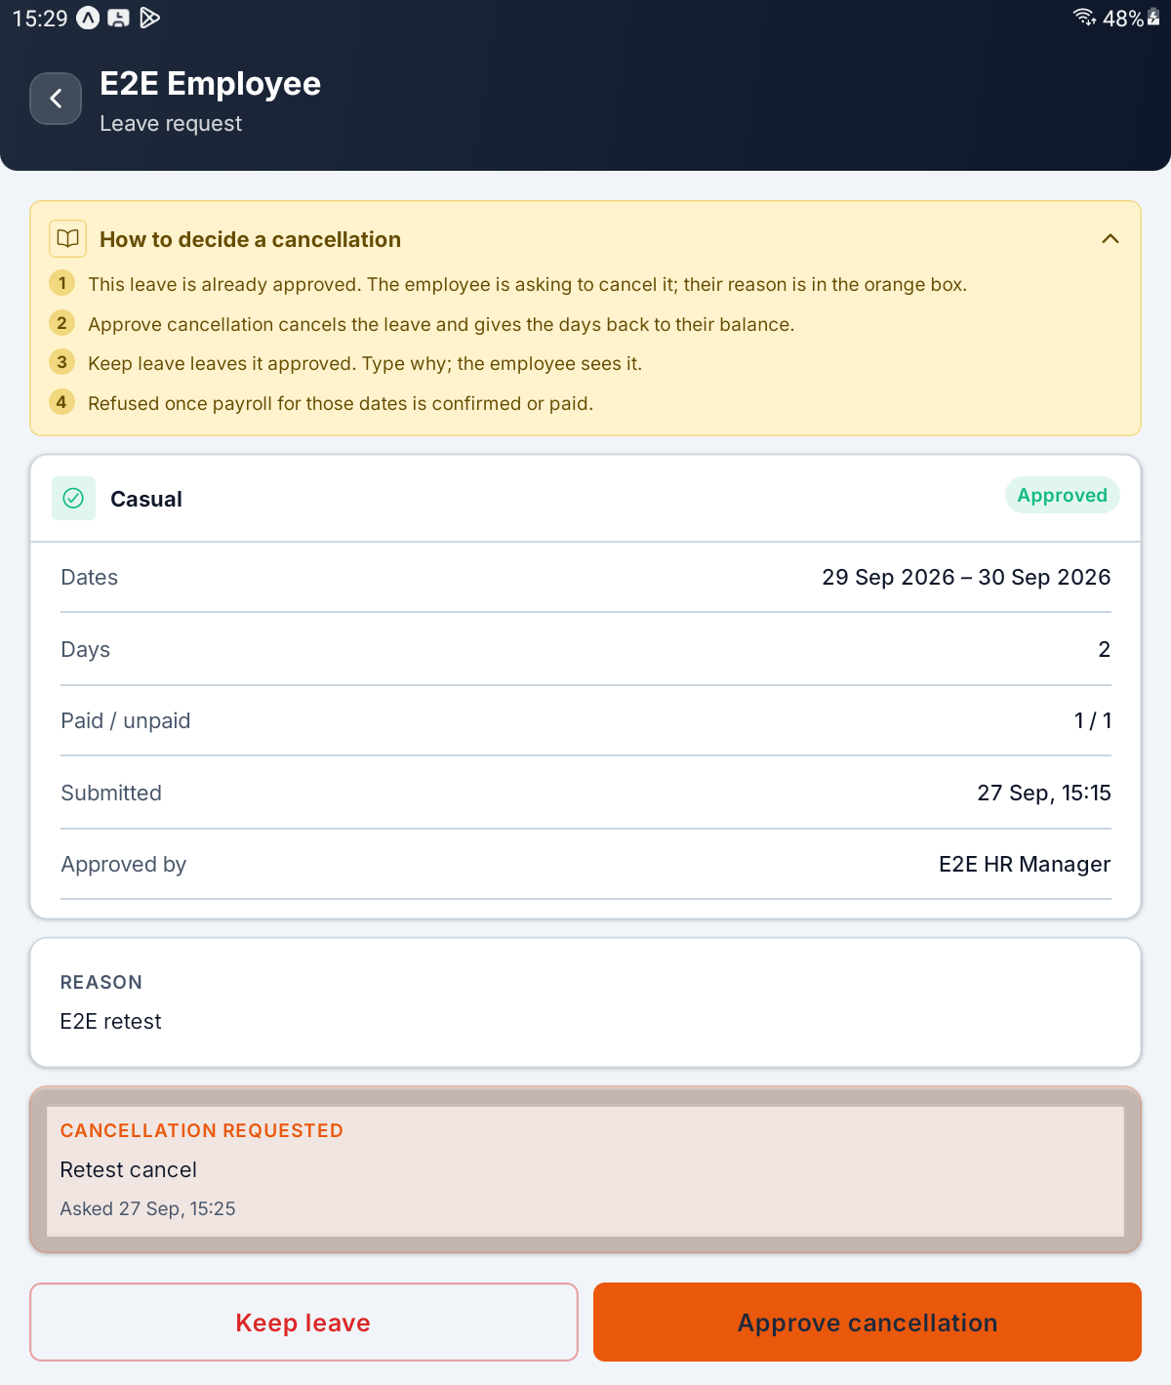
An approved leave with CANCELLATION REQUESTED, and the Keep leave and Approve cancellation buttons

Step 11 Read the Approved Leaves Report
Tap Approved Leaves Report (What was granted). The screen, titled Approved Leaves, shows one month at a time.
Three tiles total the month: Days, Paid and Unpaid. Each row below gives the employee, the leave type and dates, and the number of days (½ for a half day). An amber chip such as 1 unpaid means some of those days were not covered by the paid allowance.
A leave that runs across the end of a month appears in both months. Requests still waiting are not here — they live under All Leave Requests.
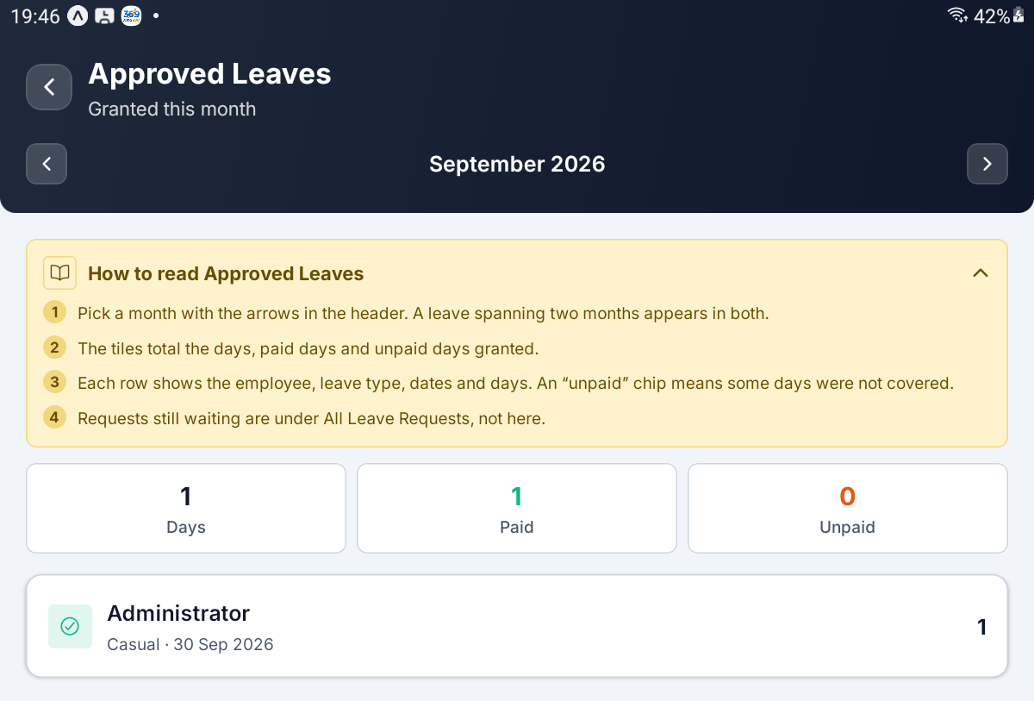
Approved Leaves — the Days, Paid and Unpaid tiles and one granted leave

PART 4 COMPENSATORY OFF AND LEAVE BALANCES

Step 12 Look Through the Comp-Off Credits
Tap Compensatory Off (Credits for days off worked).
A credit is earned when someone taps I’m working today on a weekly off or a public holiday, then checks in and out. A full day earns 1 and a short shift ½; the credit is sized when they check out.
The chips under the header filter the list. It opens on Available, with a line such as 1 day still unspent across 1 credit.
Chip | What it shows
Available | Earned and not yet spent
Declared | They said they were working, but have not checked out yet
Used | Fully taken by approved comp-off leave
Expired | Lapsed before it was used
Cancelled | Withdrawn by an administrator
All | Every credit

Each row shows the date worked, the person, the source and what is left, in the form Weekly off · 1 of 1 left · manual. manual marks a credit added by hand, and an available credit with an expiry adds until and the date.
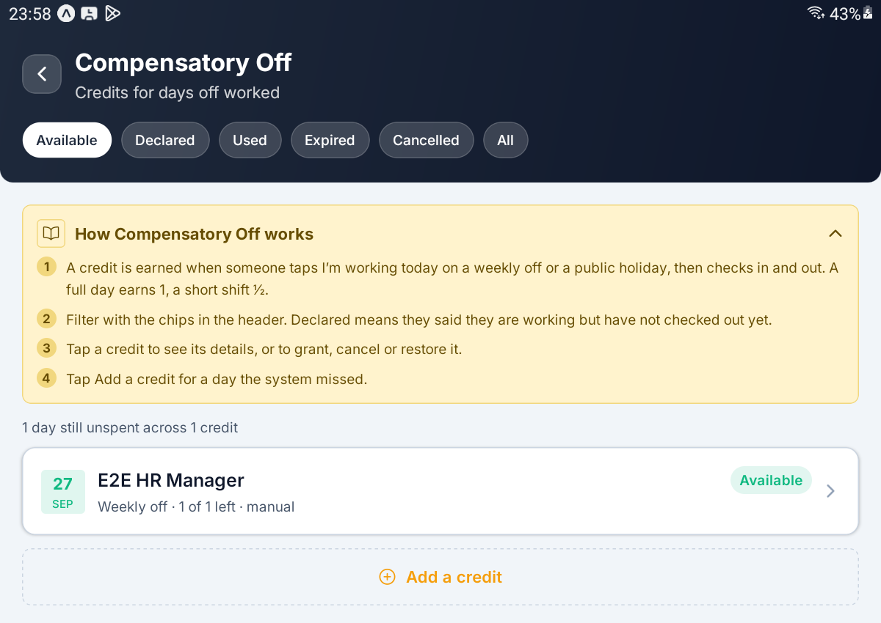
Compensatory Off — the filter chips, one available credit and the Add a credit button

Step 13 Add a Credit by Hand
Use this for a day off the system did not catch — a check-in that never happened on the phone, for example. Tap Add a credit at the foot of the list.
Field | What it controls
Employee | Who worked the day. Leaving it empty gives Pick an employee.
Day worked | The day off they worked; it cannot be in the future
Credit | Full day (1) or Half day (0.5)
Source | Weekly off or Public holiday
Note (optional) | Anything worth recording

Tap Add credit. You will see Credit added.
IMPORTANT One credit per employee per day. A credit added by hand is never resized or withdrawn by later check-ins, so check the figure before you save it.

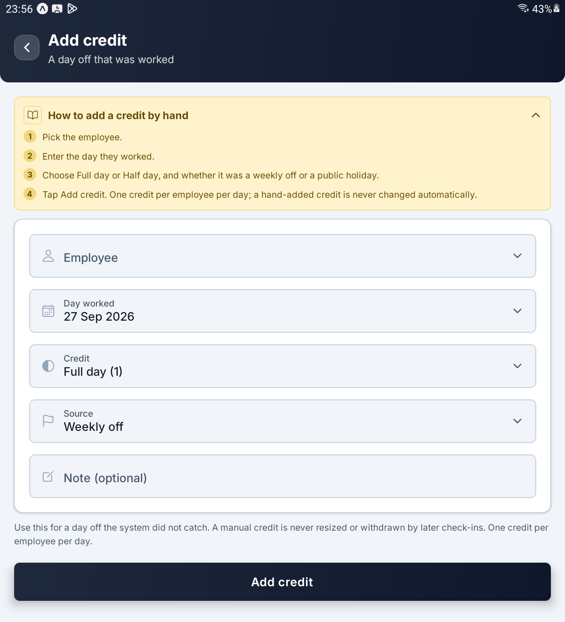
Add credit — Employee, Day worked, Credit, Source and Note

Step 14 Grant, Cancel or Restore a Credit
Tap a credit to open Comp-off credit. It shows the date and a status chip, then Employee, Source, Credited, Used, Left, Expires and Created, plus Lapsed, Holiday, Hours worked and Note where they apply. If a leave has spent any of it, a Used by card lists which.
There is no edit. The used figure comes from the employee's leave requests, not from this screen. What you can do depends on the state.
What you tap | When it is offered | What happens
Grant as earned | Declared | Makes the credit Available when the check-out never came. You see Credit granted.
Cancel credit | Anything not cancelled or used | Asks Cancel this credit? The unspent part stops counting towards the balance. You see Credit cancelled.
Restore | Cancelled or Expired | Brings the credit back. You see Credit restored.

A credit whose expiry date has passed shows Its expiry date has passed. Restoring gives it a fresh expiry window from today.
TIP If any of the credit is already used by a leave, the server refuses to cancel it until that leave is cancelled or rejected.

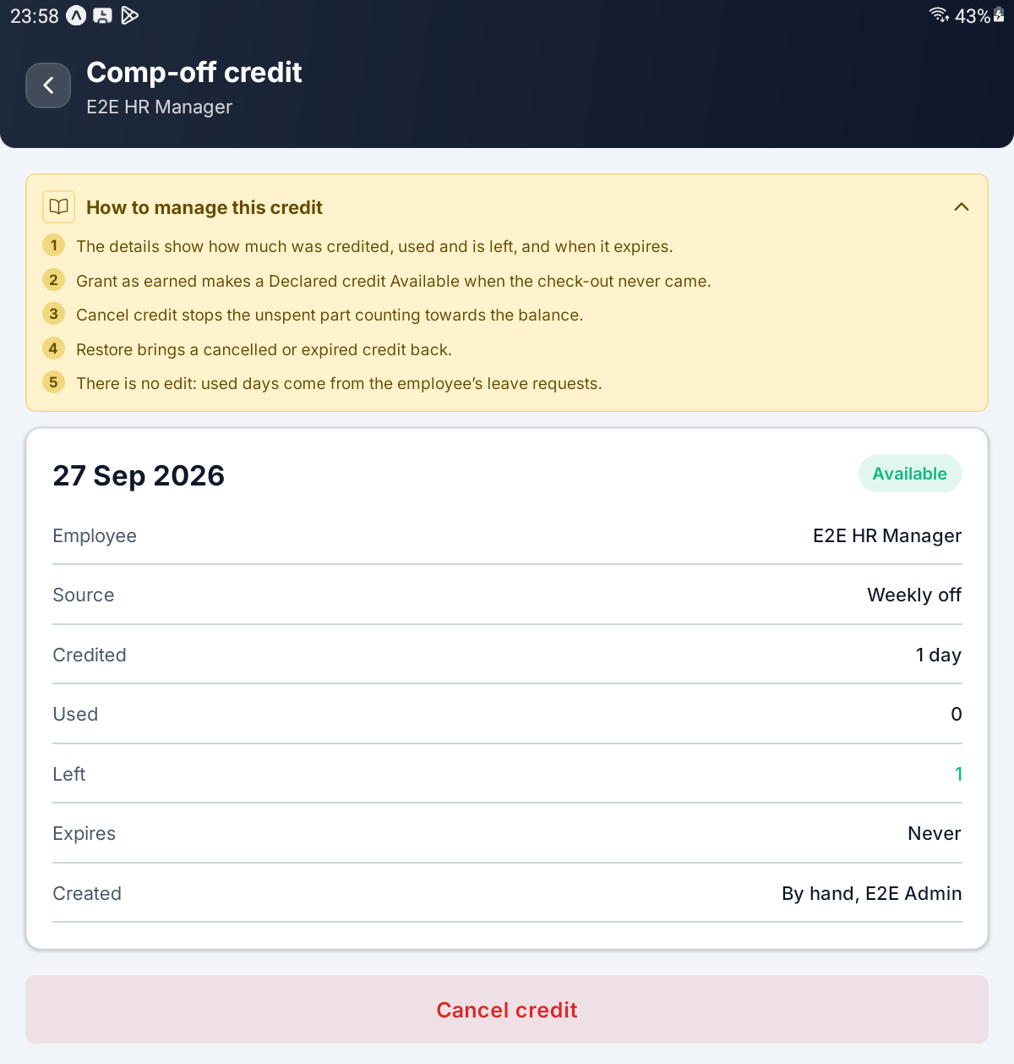
An available credit — Credited, Used, Left, Expires and the Cancel credit button

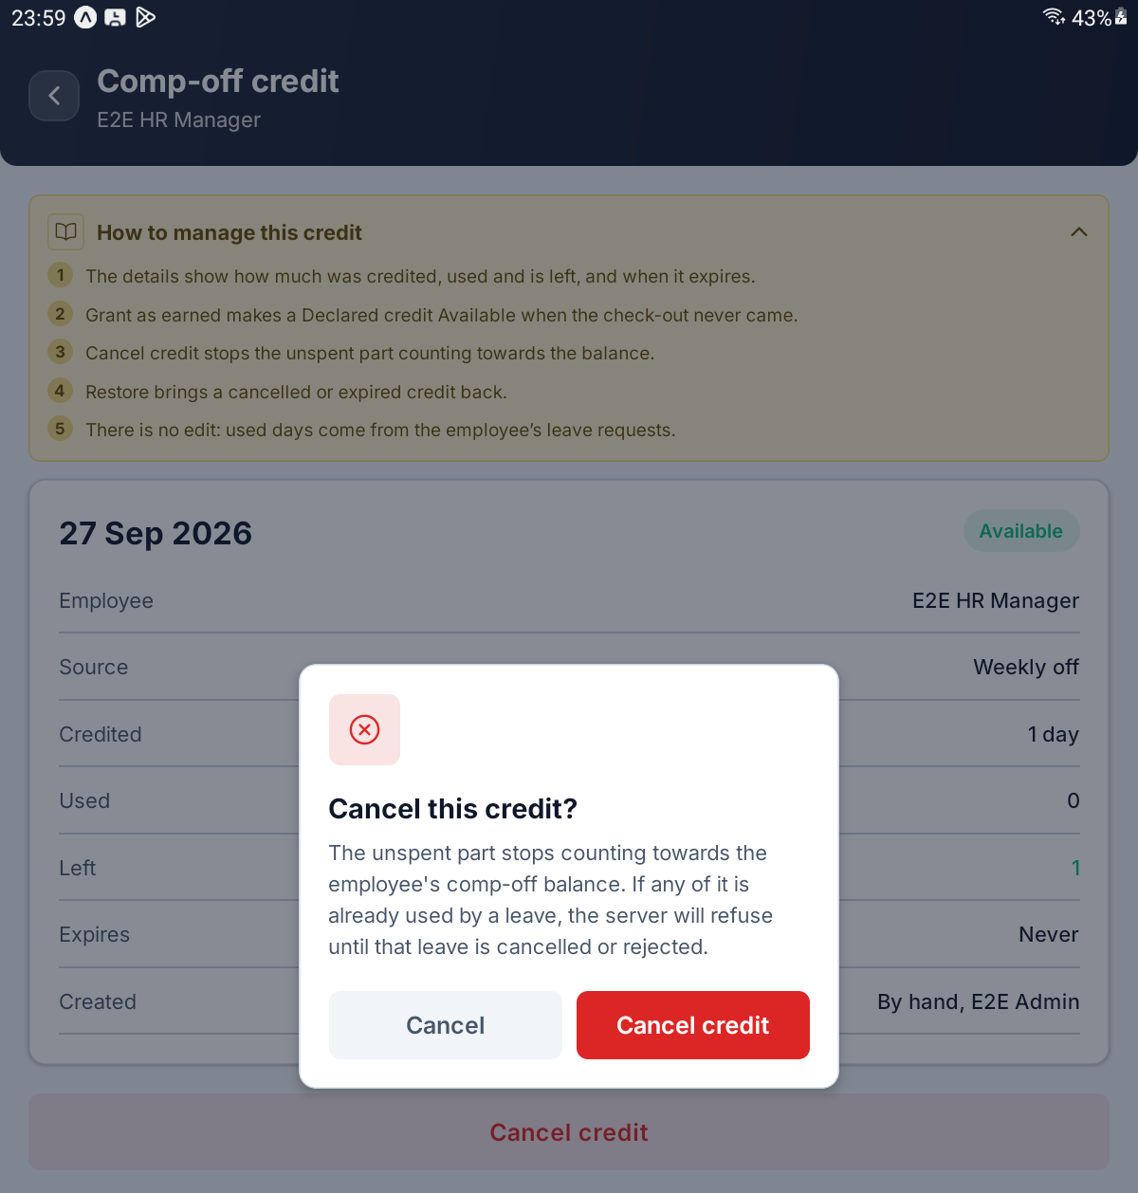
The Cancel this credit? confirmation

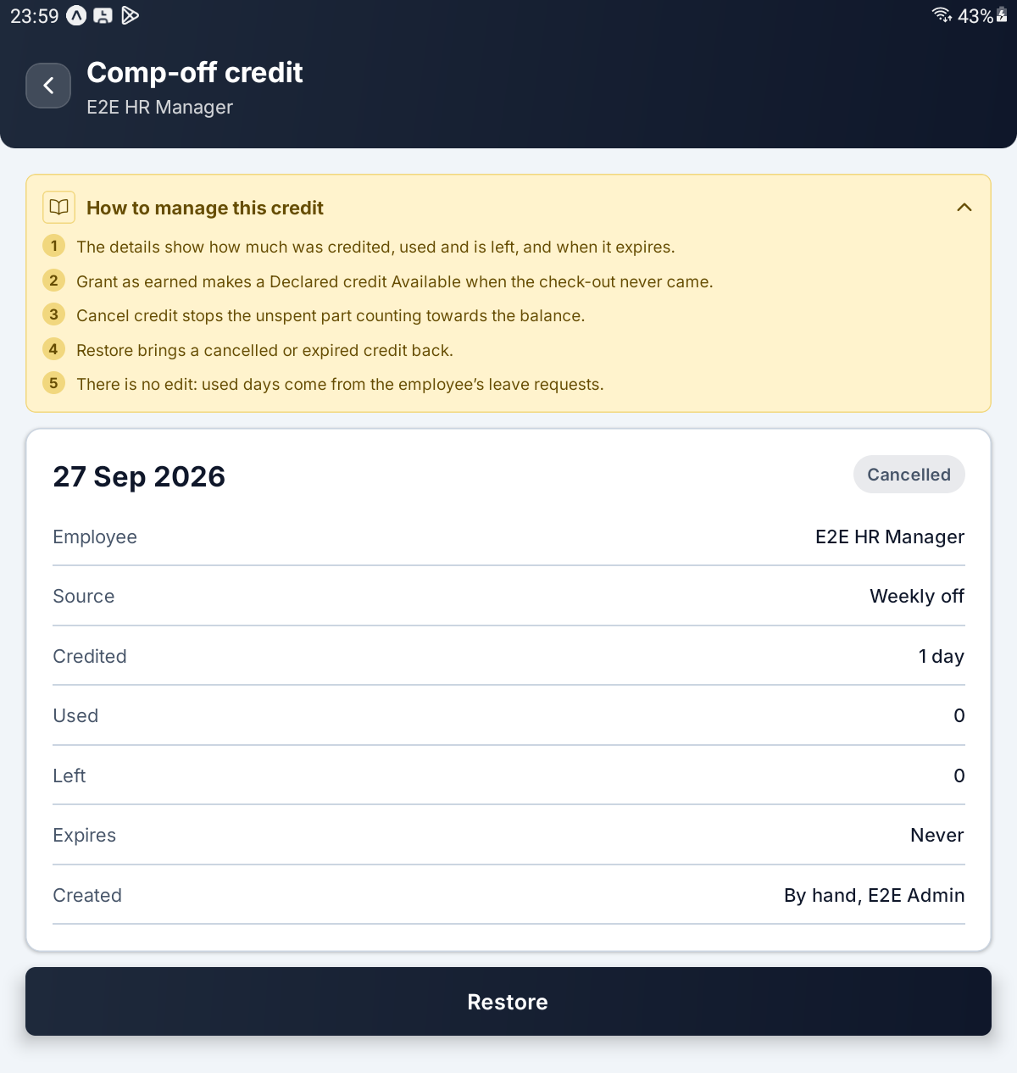
The same credit once cancelled, now offering Restore

Step 15 Read the Leave Balances
Tap Leave Balances (Paid and comp off, per employee) and pick a year with the arrows.
Each employee has a card with their department and two ledgers side by side. They never mix: a comp-off leave is paid out of the comp-off balance, never out of the paid-leave quota.
Ledger | Its three figures
Paid leave | Allowed, Taken and Left, from the Leave Policy quota
Comp off | Earned, Used and Left

Tap a card to open Compensatory Off for just that employee, with their name in the header. Add a credit from there starts with them already chosen.
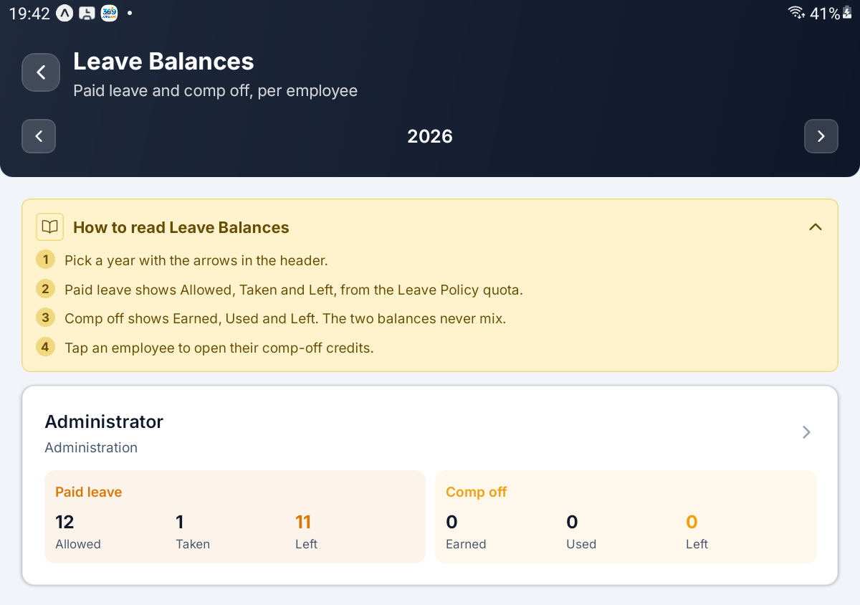
Leave Balances — one employee's Paid leave and Comp off ledgers

PART 5 LEAVE POLICY

Step 16 Set Paid and Unpaid Leave
Tap Leave Policy (Paid days, comp off). There is one policy for the company, and the header shows the company's name.
If no policy has been saved yet, an amber note warns: No leave policy is saved yet, so every leave is paid as UNPAID and deducted. These are the suggested defaults. Check them and tap Save to create the policy.
Field | What it controls
Paid leave | The master switch. Off means every leave day is unpaid, whatever the quota below says.
Paid days per year | The yearly paid allowance
Accrual per month | How much of it is earned each month
Deduct unpaid leave | Charge unpaid days against the monthly wage. Off records them without any deduction.

A request is paid only while both the yearly and the monthly allowance have room; the rest of it is unpaid. The balance strip on the employee's Leave screen reads from these two figures.
If the monthly figure can never add up to the yearly one, the app stops you with a message such as At 1/month nobody reaches 15 days in a year.
IMPORTANT Paid leave does not carry forward. It resets each year, and there is deliberately no carry-forward switch for it.

[ IMAGE 18 — not captured yet ]
Leave Policy — the Paid leave and Unpaid leave cards

Step 17 Set Compensatory Off
The Compensatory off switch decides whether working a weekly off or a public holiday earns a day back. A full day worked earns 1, a short day 0.5.
With it on, three more controls appear.
Field | What it controls
Expires after (days, 0 = never) | Days from the date worked until an unused credit lapses
Carry forward | Let unused comp offs roll into next year, up to the cap below.
Maximum comp offs carried | The cap, shown when Carry forward is on

Every number here must be 0 or more; the expiry field says so with Days, 0 or more (0 never expires).
[ IMAGE 19 — not captured yet ]
The Compensatory off card with expiry, Carry forward and the cap

Step 18 Email HR When Leave Is Submitted
The Notifications card holds one switch, Email HR on submission. With it on, an email goes to the addresses you list the moment anyone submits a leave request. It needs an outgoing mail server set up on the web console.
Type the addresses into Recipients (comma-separated), for example two addresses separated by a comma.
Tap Preview email to see exactly what HR will receive. The popup, Email preview (sample), shows a sample request on white paper with its subject, the request's details and a Review and approve button, and says how many people it goes to. Tap Close when you are done.
TIP The preview uses the recipients already saved. If you have just changed them, tap Save first and preview afterwards.

[ IMAGE 20 — not captured yet ]
The Email preview (sample) popup over the Notifications card

Step 19 Save the Policy
Tap Save. You will see Leave policy updated. (or Leave policy created. the first time) and be returned to the menu. Cancel leaves without saving.
IMPORTANT Policy changes apply to requests decided from now on. Leave already approved keeps the paid and unpaid split it was given.

PART 6 WORK FROM HOME REQUESTS

Step 20 Work the WFH Queue
Tap All WFH Requests (Approve or reject). Like the leave queue it opens on Pending, and each card shows who asked, Work from home, the date and a status chip, with auto where the server approved it.
Chip | What it shows
Pending | Waiting for a decision
All | Everything
Approved | Granted, day not yet worked
Done | Checked in and out on the day
Rejected | Turned down

A request can also show Checked in, Cancelled or Expired under All.
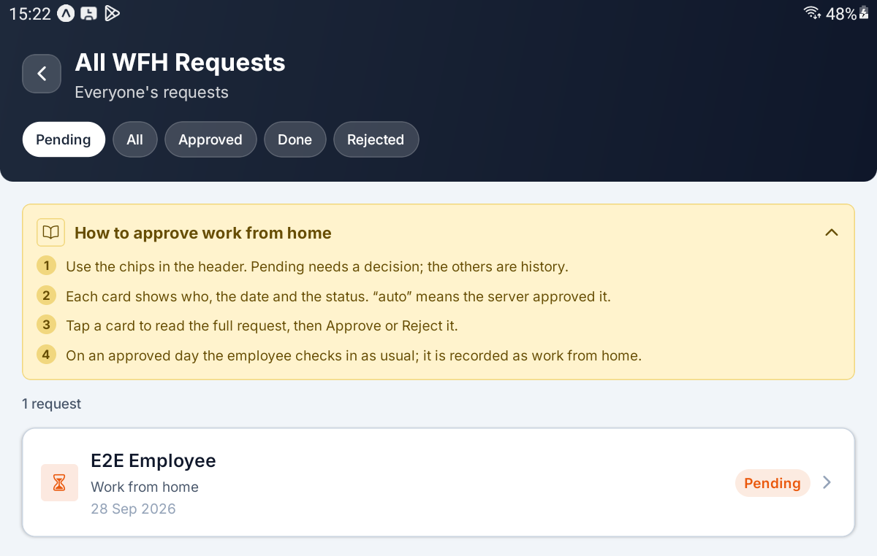
All WFH Requests — the filter chips and one pending request

Step 21 Decide a WFH Request
Tap a card. The request shows Date, Submitted and the REASON, and, once the day has been worked, Worked with the check-in time and hours.
What you tap | What happens
Approve | Asks Approve this request? — the person will be able to check in from home on that date
Reject | Asks Reject this request? and for a Reason for rejection, which is required

On an approved day the employee checks in as usual, and the day is recorded as work from home.
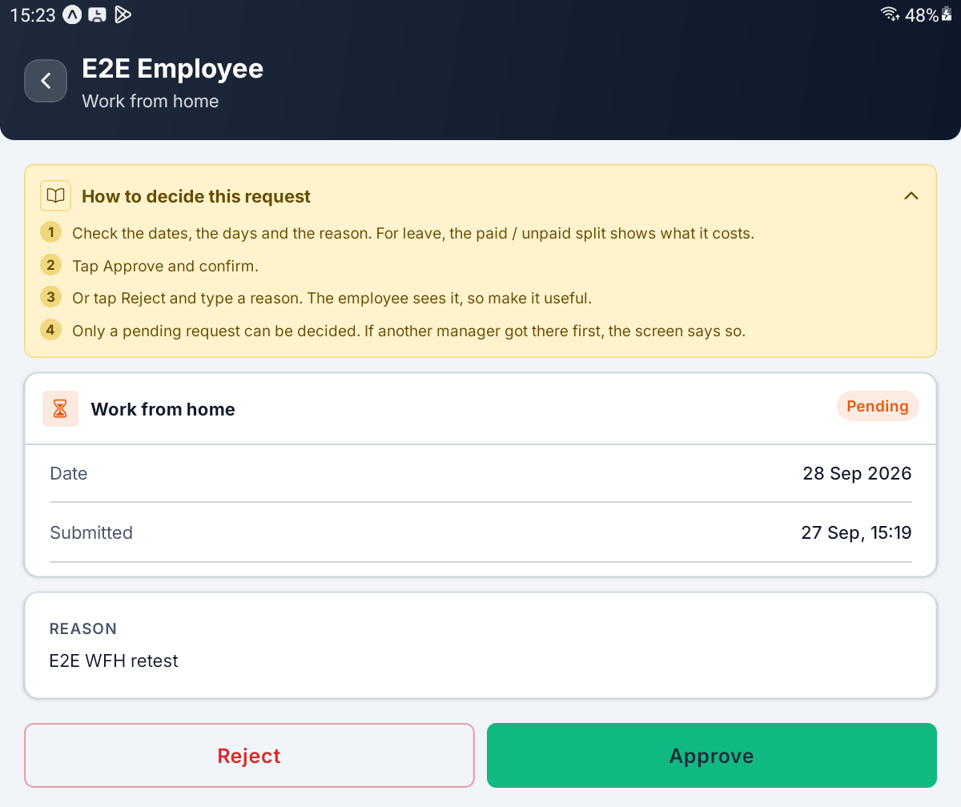
A pending work-from-home request with Reject and Approve

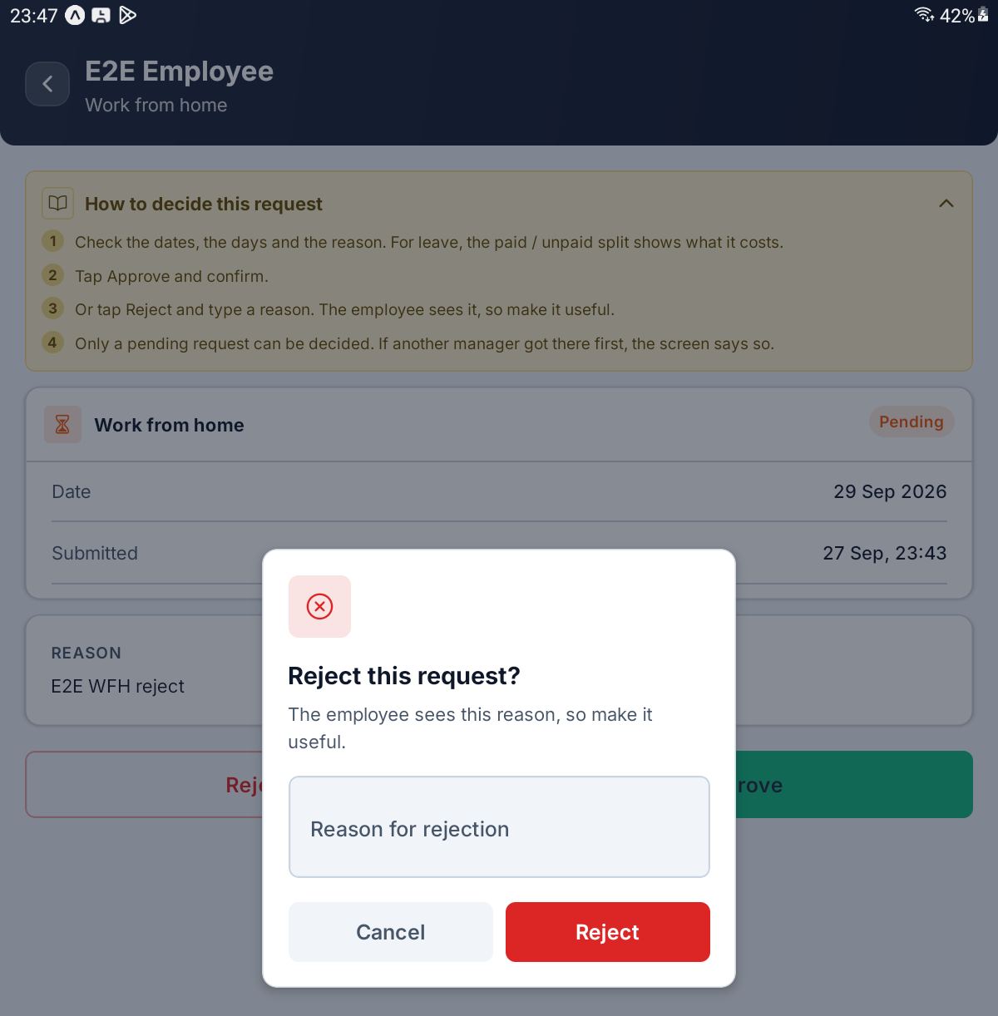
The Reject this request? prompt with its reason box

PART 7 OFFICE HOURS, HOLIDAYS AND AUTO-APPROVAL

Step 22 Read the Rule Cards
Tap Office Hours & Working Days (Grace, ladder, working days). The screen, titled Office hours, lists one card per set of rules.
The Company-wide card applies to everyone. A department card overrides it for the people in that department — A department row takes precedence over the company-wide one for its own people.
Each card shows the office hours, the grace minutes and the paid hours, for example 08:00 – 17:00, 16 min grace and 9 h paid.
What you see | What it means
Company-wide | The rules everyone falls back to
A department name | Rules for that department only
Tracking off | Late tracking is switched off for that card
View only | Your role can read these rules but not change them

IMPORTANT You cannot add a new set of rules in the app — there is no Add button. A department's own rules are created on the web console; here you open and change the ones that exist.

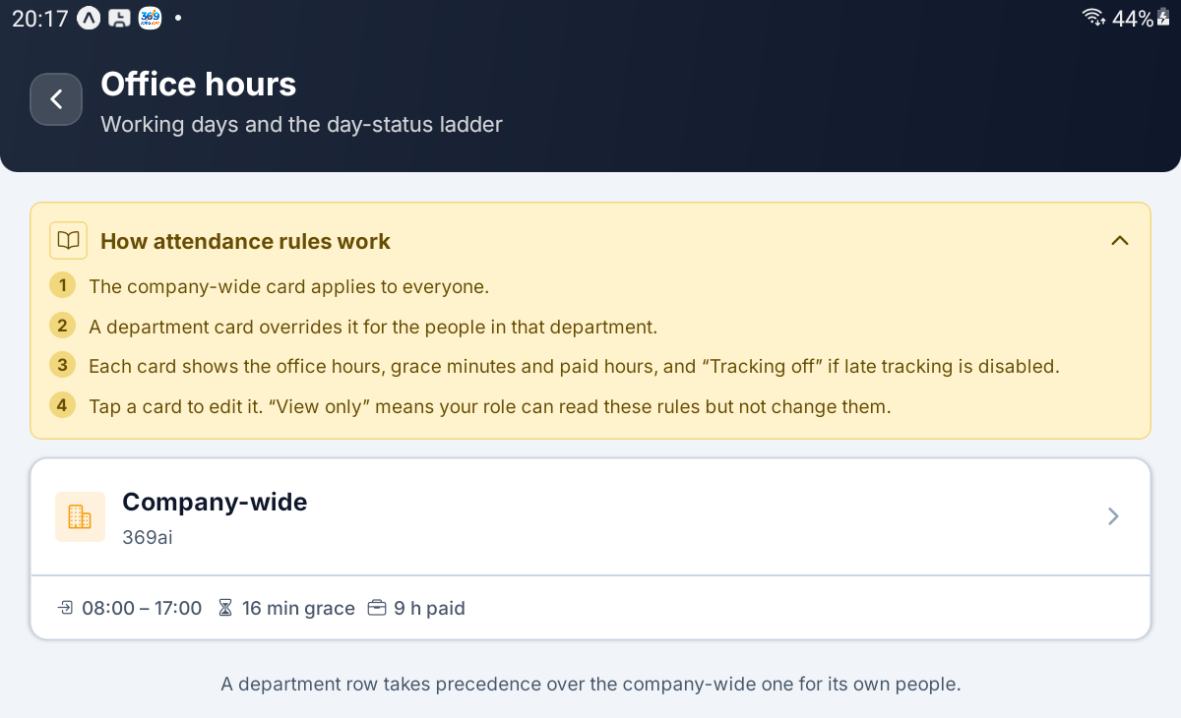
Office hours — the Company-wide card with its hours, grace and paid hours

Step 23 Set Late Tracking and the Scope
Tap a card to open its rules. The form is long and runs in sections, top to bottom.
Field | What it controls
Late tracking | The master switch. Off, people can still check in, but nobody is marked late and no late figures are kept
Require late reason | Asks for a reason when a late check-in is entered or edited on the web console. App check-ins are never blocked
Company | The company these rules belong to; required
Department | A department, or Company-wide (no department)
Office timezone | The office clock; empty means Each employee's own

Every check-in is converted to the office timezone before it is compared with office start, so where the server sits does not matter.
TIP Switching late tracking off hides the grace settings and shows a note. When you switch it back on, use Recompute last 3 months to restore the figures it stopped keeping.

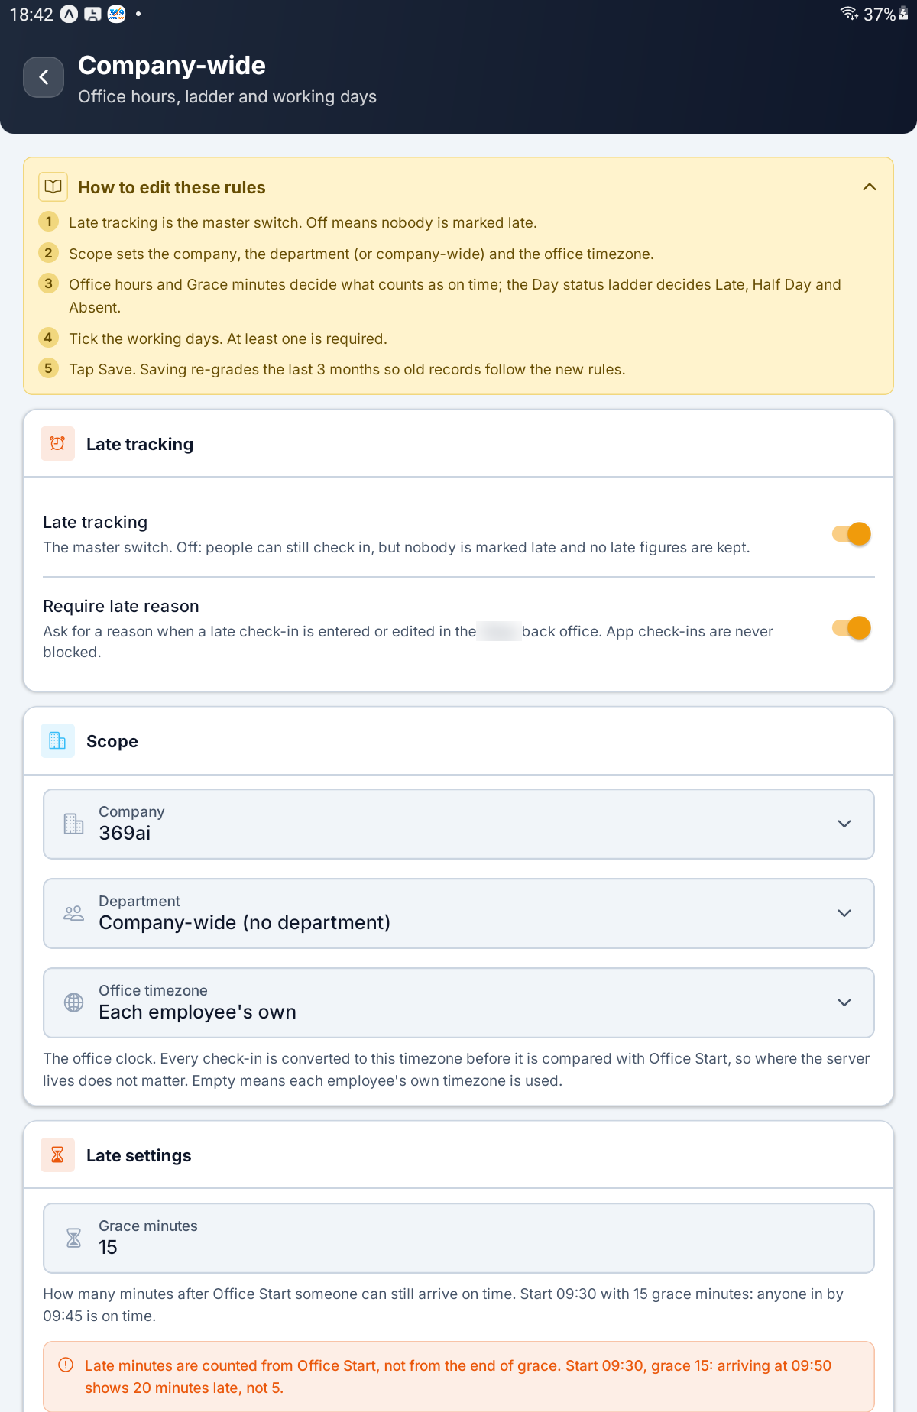
The rules form — Late tracking, Scope and the top of Late settings

Step 24 Set Office Hours and Grace
Field | What it controls
Grace minutes | How many minutes after office start someone can still arrive on time
Office start | Typed as HH:MM, for example 09:30
Office end | Must be after office start
Daily paid hours | Filled in from the office hours, and meant to be typed over

Start 09:30 with 15 grace minutes means anyone in by 09:45 is on time. Daily paid hours fills itself in when you change the hours: 09:30–18:30 spans 9 hours, but only 8 are paid if lunch is unpaid, so type 8.
IMPORTANT Late minutes are counted from office start, not from the end of grace. Start 09:30, grace 15: arriving at 09:50 shows 20 minutes late, not 5.

[ IMAGE 26 — not captured yet ]
The Late settings and Office hours sections

Step 25 Set the Day Status Ladder
Three rules decide each day's label. Each one ships switched off — 00:00, or 0 for the ratio — and with all three off nobody is ever marked Half Day or automatically Absent, and a late arrival stays Late however late they come.
Field | What it controls
Late window ends | When the Late period ends. Check in after this and the day shows Present, with the real arrival time in brackets. No check-in at all by this time on a working day means Absent, stamped automatically
Half day after | Check in after this time and the day becomes a Half Day
Half day below ratio | A fraction of the daily paid hours between 0 and 1; 0.5 means half. Check out having worked less than this share and the day becomes a Half Day

Half day after is checked first. If it is earlier than Late window ends, anyone arriving between the two is marked Half Day, not Late.
Tap How a day gets its label to unfold the full ladder, and the money that goes with each rung.
What happened | Label | What it costs
In by office start plus grace | Present | Nothing
In after that, before the late window ends | Late | Nothing — recorded, never charged
In after the late window ends | Present | Nothing; the arrival time is shown in brackets
In after Half day after, or worked less than the ratio | Half Day | Half a day's pay
Never checked in on a working day | Absent | The day is simply not earned

A further switch at the foot of this section lets a linked work-tracking app create the check-in when someone starts their workday there. It does nothing unless that link is installed on the server.
IMPORTANT Until Late window ends is set, absentees are never stamped: Day Status and Absent Today stay empty for people who did not come in.

[ IMAGE 27 — not captured yet ]
The Day status ladder section with Late window ends, Half day after and Half day below ratio

Step 26 Tick the Working Days and Save
Working days is a row of seven letters, Monday to Sunday. Green days are working days. Unticked days are days off: nobody is marked Absent on them, and they are left out of the working-day count that the monthly wage is divided by. At least one day must be ticked.
Tap Save. The app checks every field first and tells you what to fix.
If you see this | What is wrong
Use HH:MM, e.g. 09:30. | A time is not in hours and minutes
The office cannot end before it starts. | Office end is before office start
Outside office hours, so it would never apply. | A ladder time falls outside the office day
A fraction between 0 and 1 — 0.5 is half a day. 0 switches it off. | The ratio was typed as a percentage
Pick at least one working day — zero would break every daily rate. | No working day is ticked

A good save shows Attendance rules updated. Saving a rule change re-grades the last 3 months of attendance, so old records follow the new rules.
Recompute last 3 months does the same re-grading on demand. It asks Recompute 3 months? and confirms with Late and leave figures recomputed for the last 3 months. You rarely need it — mostly after switching late tracking back on.
[ IMAGE 28 — not captured yet ]
Working days, the Save button and Recompute last 3 months

Step 27 Look Through the Public Holidays
Tap Public Holidays (Excluded from working days) and pick a year with the arrows.
Each row shows the date, the holiday's name, the weekday and the company. Not counted means the holiday is recorded but does not change payroll.
A holiday is always paid and nobody is marked Absent on it. That works because counted holidays leave the working-day count the monthly wage is divided by, so every holiday you add raises everybody's daily rate for that month.
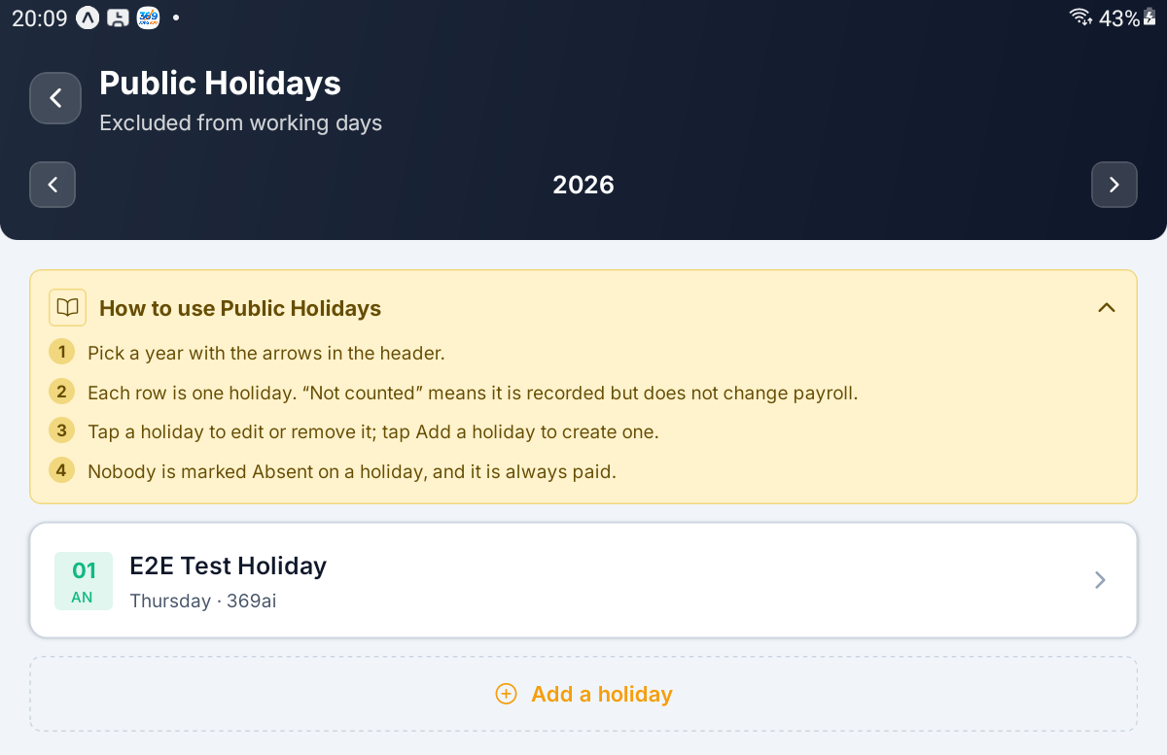
Public Holidays — the year arrows, one holiday and the Add a holiday button

Step 28 Add, Edit or Remove a Holiday
Tap Add a holiday, or tap a holiday to edit it.
Field | What it controls
Holiday name | Required — Give the holiday a name.
Date | The day itself, chosen from a calendar
Company | Which company it applies to; usually filled in for you
Counts as a non-working day | On, it leaves the working-day count and raises the daily rate for that month. Off records the date without touching payroll

Tap Add holiday or Save changes. You will see Holiday added. or Holiday updated.
Remove holiday asks Remove this holiday? and warns that this changes payroll: the day goes back into the working-day count, which lowers everyone's daily rate for that month. Tap Remove to confirm; you will see Holiday removed.
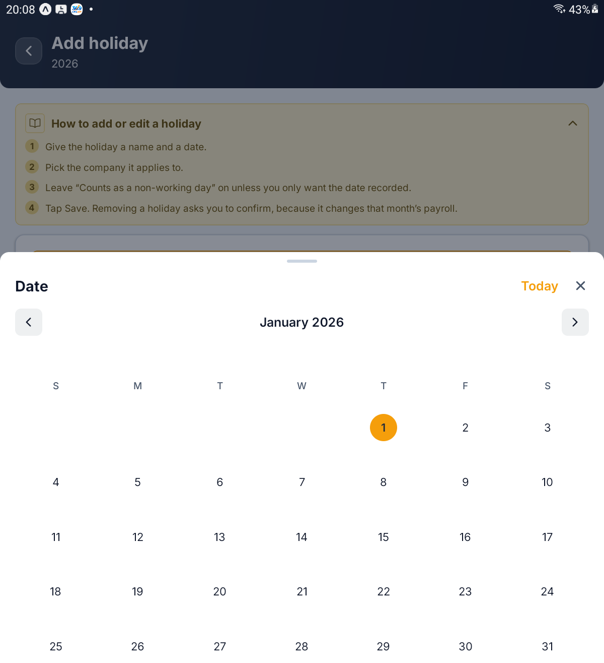
Add holiday with the Date calendar open

Step 29 Set Auto-Approval
Tap Auto-Approval (Leave and WFH, one policy). One screen covers both, but the two switches are independent.
Field | What it controls
Auto-approve leave | Approve a pending leave request automatically once it has waited this long
Auto-approve WFH | The same, for work-from-home requests
Wait | How long a request may wait, shown when its switch is on
Unit | Minutes, Hours or Days

With either switch on, an amber note warns that requests left undecided for the delay are approved by the server without anyone looking at them. Tap Save; you will see Auto-approval updated.
IMPORTANT A wait of 0 switches auto-approval off, whatever the switch says. Save one that way and the app tells you so, for example Saved, but a wait of zero leaves leave auto-approval switched off.

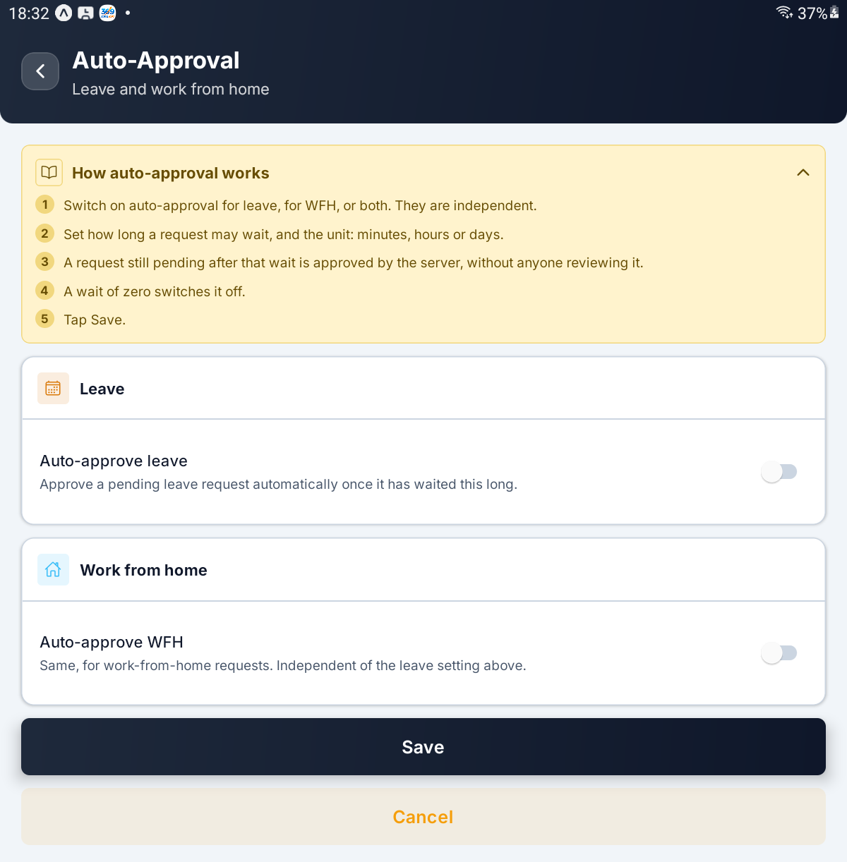
Auto-Approval — the Leave and Work from home switches, with Save and Cancel

PART 8 EMPLOYEE DETAILS

Step 30 Choose What Employee Details Are Kept
Tap Field Settings (What My Details shows). Everyone (defaults) decides which employee details are recorded for all staff. An Exception row applies to one employee and replaces the defaults for them — it is not merged with them. Each row counts how many fields are on, for example 12 of 21 shown.
Tap a row. The form has five sections — Salary, Statutory, Bank, Personal and Employment — each with a master switch such as Show the personal section. With a section on, switch the individual fields underneath.
Section | Fields inside it
Salary | Salary effective from, Annual CTC, Salary payment mode
Statutory | Income tax regime, Professional tax state
Bank | IFSC code, Branch, Account category
Personal | Blood group, Father's name, Mother's name, Emergency contact relationship, Second emergency contact
Employment | Confirmation date, Notice period, Previous employment

Tap Save; you will see Field settings updated.
IMPORTANT In the app, an employee's My details shows only personal details, qualifications and previous employment. Salary, bank and statutory details never appear there whatever these switches say; those switches govern the web console.

TIP Rows are not created in the app. If the list says Nothing configured, or you need a new exception for one person, set it up on the web console first.

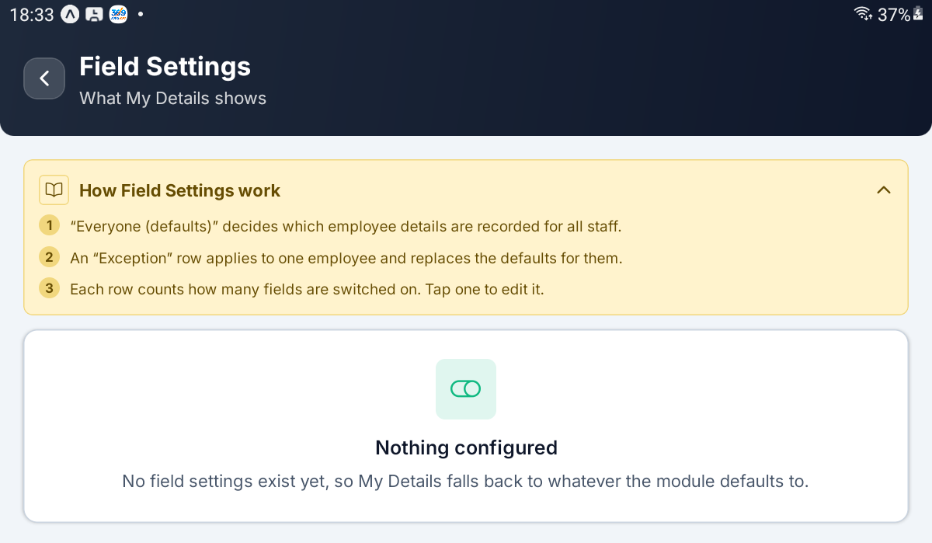
Field Settings with nothing configured yet

Step 31 Build the Salary Components
Tap Salary Components (Earnings and deductions). Earnings add up to the gross; deductions come off it to give the net.
Each row shows the component's name, its code and how it is worked out — for example BASIC · Fixed amount — with an Earning or Deduction chip and the amount or percentage.
IMPORTANT An employee's earnings must add up to their Monthly Wage. If they do not, their payslip is flagged Mismatch and the payroll run cannot be confirmed.

[ IMAGE 33 — not captured yet ]
Salary Components — earning and deduction rows and the Add a component button

Step 32 Add or Change a Component
Tap Add a component, or tap a row to edit it.
Field | What it controls
Name | Required — Give the component a name.
Code | A short code in capitals, such as BASIC or HRA
Type | Earning or Deduction
Computation | Fixed amount, Percentage of another component or Percentage of gross
Default amount | For a fixed amount
Percentage | Between 0 and 100, for either percentage
Percentage of | The component it is a percentage of
Company | Required
Sequence | The order components are listed in on the payslip

Only a deduction can be a percentage of gross; an earning set that way gives Only a deduction can be a percentage of gross.
Tap Add component or Save changes. Remove component asks Remove this component?: any employee whose pay structure uses it loses that line, but payslips already generated are not changed.
[ IMAGE 34 — not captured yet ]
Add component — Name, Code, Type, Computation and amount

Step 33 Set the Statutory ID Types
Tap Statutory ID Types (PAN, Aadhaar, UAN). Each row is one kind of identity number, with its code (or No code), validated when it carries a pattern, and Required and Confidential chips.
Tap Add an identifier type, or tap a row.
Field | What it controls
Name | Required
Code | A short code in capitals
Company | Required
Sequence | The order they are listed in
Validation pattern | A pattern the value must match; empty accepts anything
Message when it fails | What the employee is told when the value does not match
Required | Every employee must have this identifier on file
Confidential | Kept off screens that are not the employee's own; on by default

A broken pattern is caught before saving with That is not a valid regular expression. Tap Add identifier or Save changes. Remove identifier asks Remove this identifier type?: employees who already hold one keep it, but nobody can be asked for it again.
TIP Statutory numbers never show on an employee's My details screen in the app.

[ IMAGE 35 — not captured yet ]
Statutory ID Types — rows with their Required and Confidential chips

PART 9 PAYROLL AND REPORTS

Step 34 Create a Payroll Run
Tap Payroll Runs (Generate, confirm, mark paid). There is one run per company per month. Each row shows the month, the run's reference and employee count, a Draft, Confirmed or Paid chip, and the total net.
Tap New payroll run. Pick the Month, type the Year and choose the Company, then tap Create. The period and reference are set by the server from the month and year.
You will see Payroll run created. Generate the payslips next. and the new run opens. A month that already has a run for that company is refused with, for example, A run already exists for September 2026.
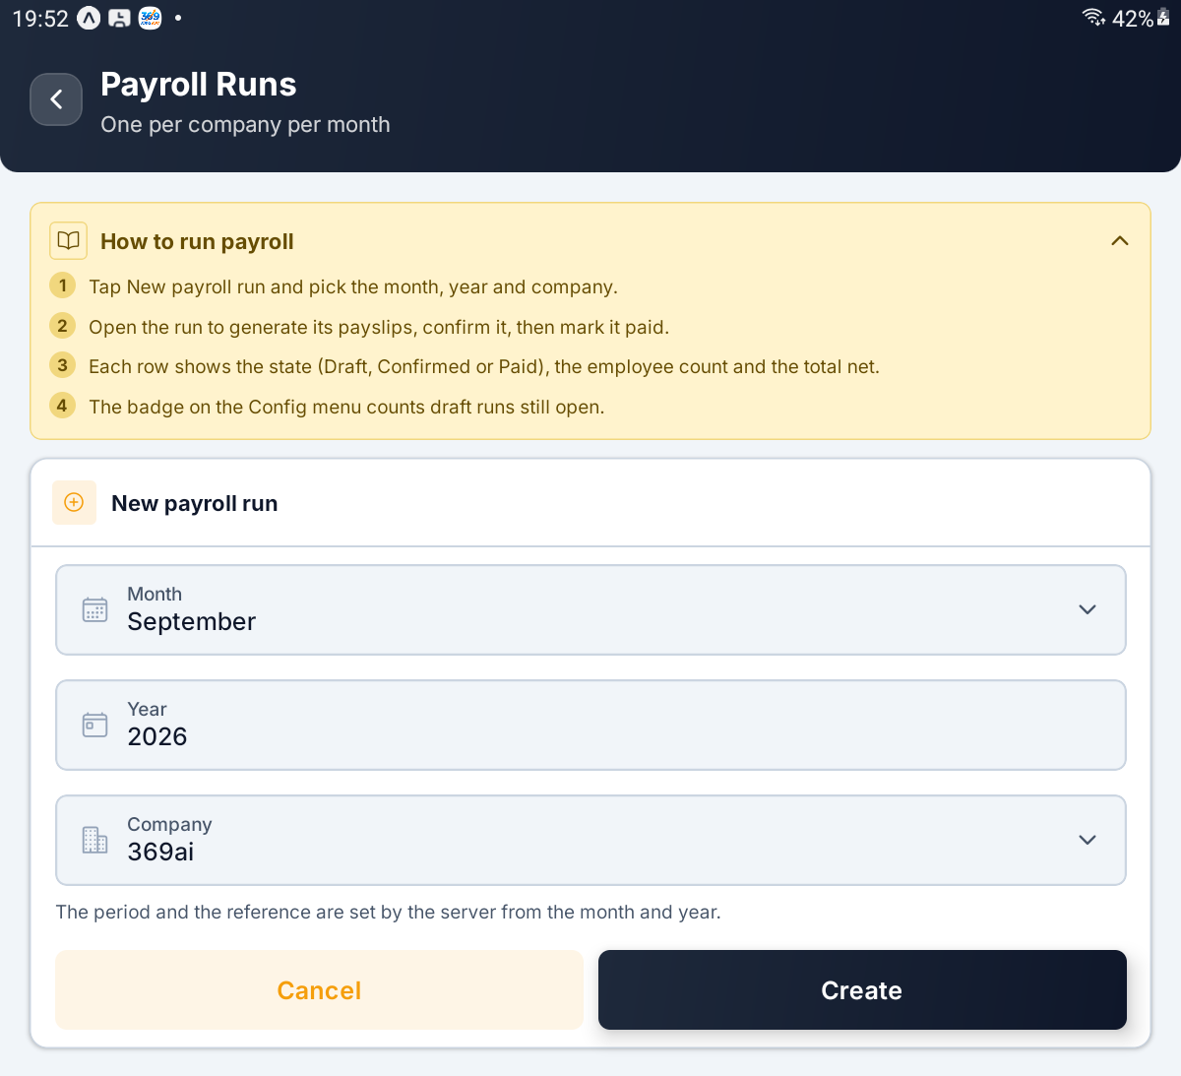
The New payroll run card — Month, Year, Company, Cancel and Create

Step 35 Generate, Confirm and Pay
The run shows its company and state, then Period, Pay date, Employees, Gross earnings, Deductions and Net pay, and a Payslips row with the count. Which buttons appear depends on the state.
What you tap | When it is offered | What happens
Generate payslips | Draft, no payslips yet | Builds one payslip per employee from attendance and salary
Generate again | Draft | Recalculates every payslip; anyone who has left the company loses theirs
Confirm run | Draft with payslips | Locks the payslips to these figures. You see Run confirmed.
Back to draft | Confirmed | Reopens the run so the payslips can be regenerated
Mark paid | Confirmed | Marks the money as gone out. You see Run marked paid.

Every button asks you to confirm first.
If any payslip's earnings disagree with that employee's Monthly Wage, an amber note lists each one with both figures, and the run cannot be confirmed until they match. Fix the salary components and generate again.
IMPORTANT Mark paid cannot be undone. A paid run can never be reopened, because the payslips have been given to employees. Payslip PDFs are not produced in the app; print them from the web console.

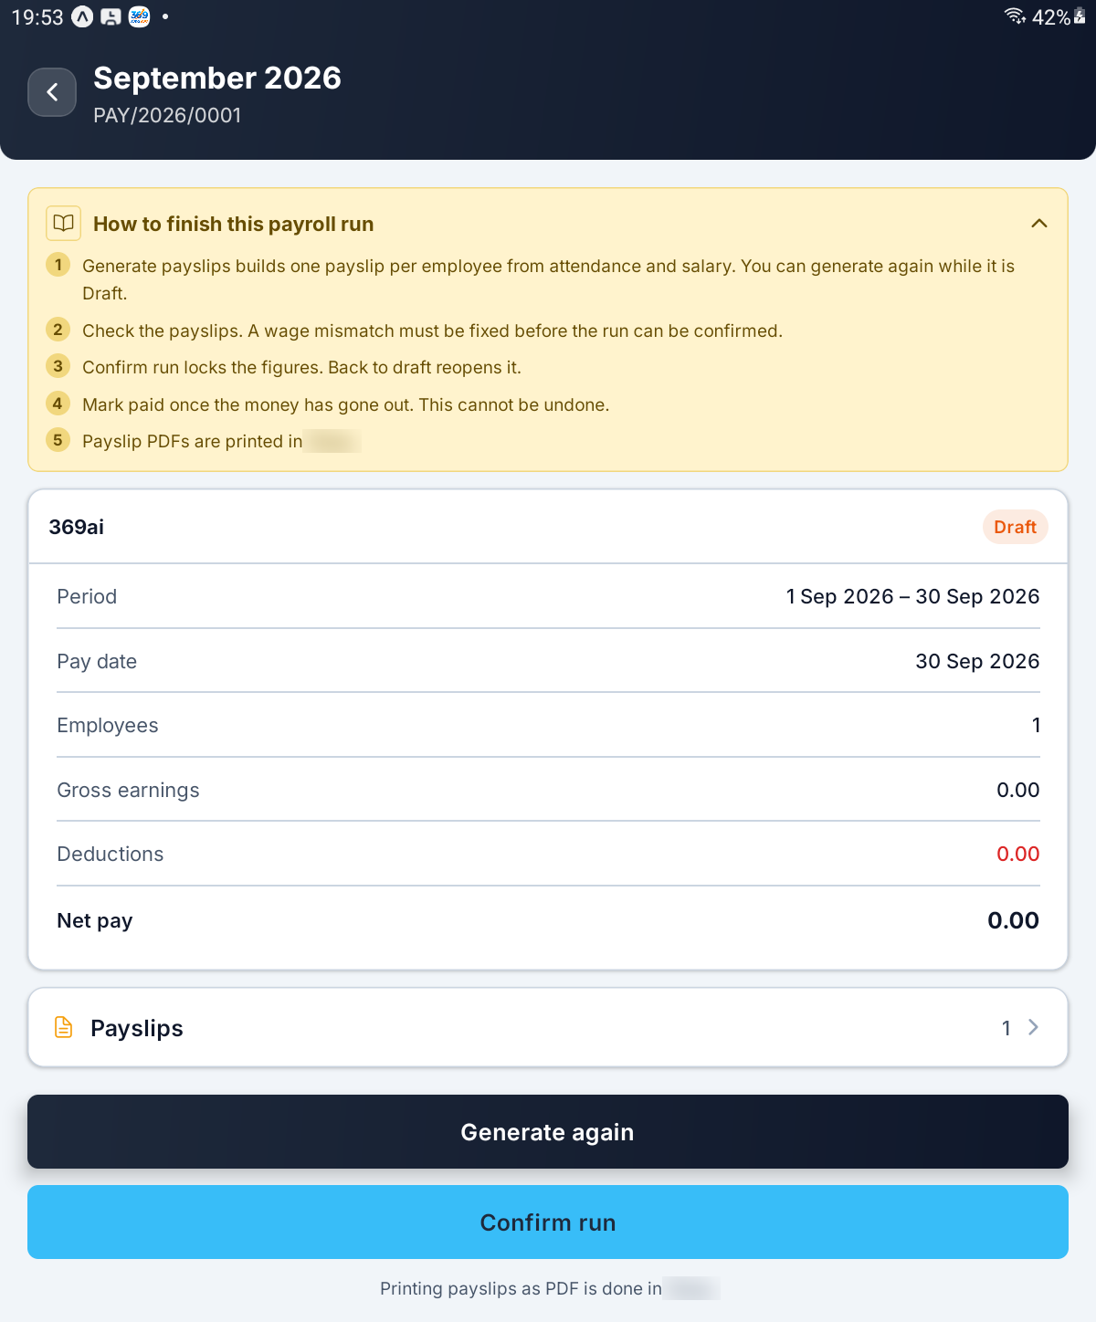
A draft run — the totals, the Payslips row, Generate again and Confirm run

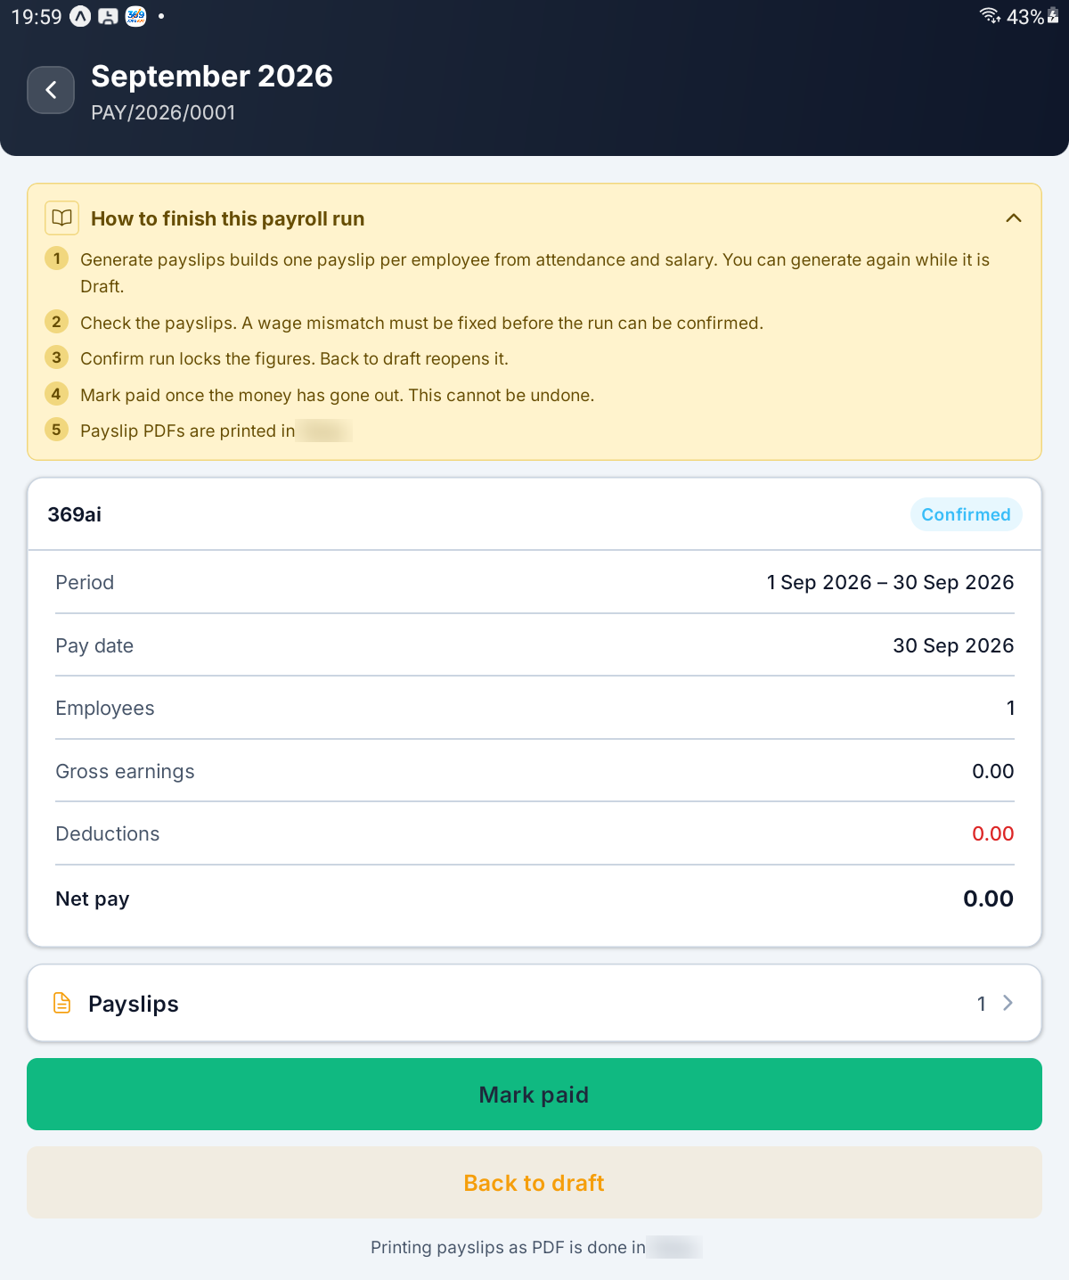
A confirmed run offering Mark paid and Back to draft

Step 36 Read a Payslip
Tap Payslips on a run for that month's payslips, or Payslips on the menu for every payslip in every run. Each row shows the employee, department, paid days and net pay, with a Mismatch chip where the earnings disagree with the Monthly Wage.
Tap a payslip for the full breakdown. It is read-only; to change it, generate the run again.
Section | What it shows
Earnings | Every earning line, then Gross earnings
Deductions | Every deduction line, then Total deductions
NET PAY | The amount paid, in figures and in words
Attendance | Working days, Present, Half days, Absent, Paid leave, Unpaid leave, Loss of pay days and Paid days, plus Comp off when there is any
Leave balance | Opening, Taken and Closing for the month

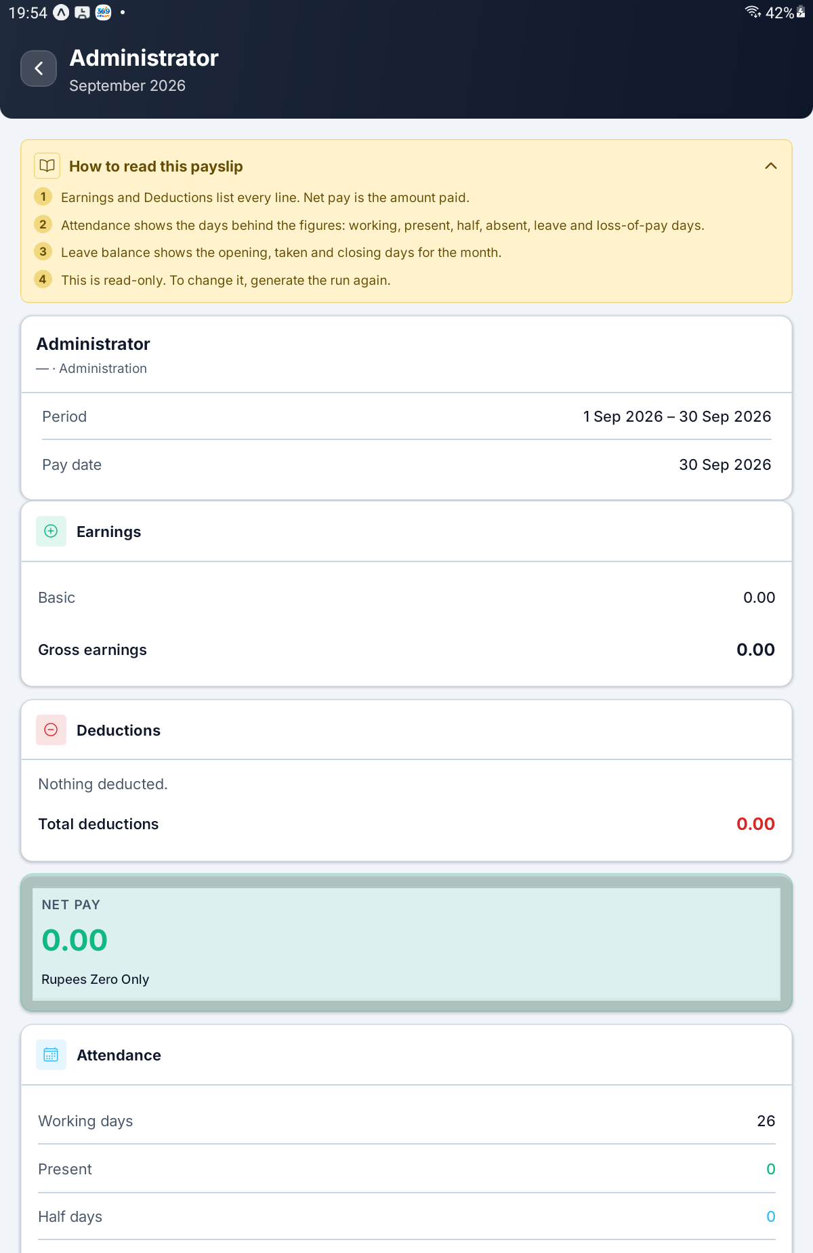
A payslip — Earnings, Deductions, NET PAY and the start of Attendance

Step 37 Generate a Month's Report
Tap Generate Report (A month, per employee).
Field | What it controls
Month and Year | The month to report on
Company | Which company
Department | One department, or All departments
Employees | All employees or Selected employees
Which employees | The people to include, when Selected employees is chosen

Picking employees by name ignores the department filter. Selected employees with nobody picked gives Pick at least one employee, or switch to All.
Tap Generate. It recalculates the whole month for everyone in scope, so it takes a moment. You will see Report generated., the report opens, and it is saved under Past Reports.
TIP PDF and Excel exports of the report are made from the web console, not in the app.

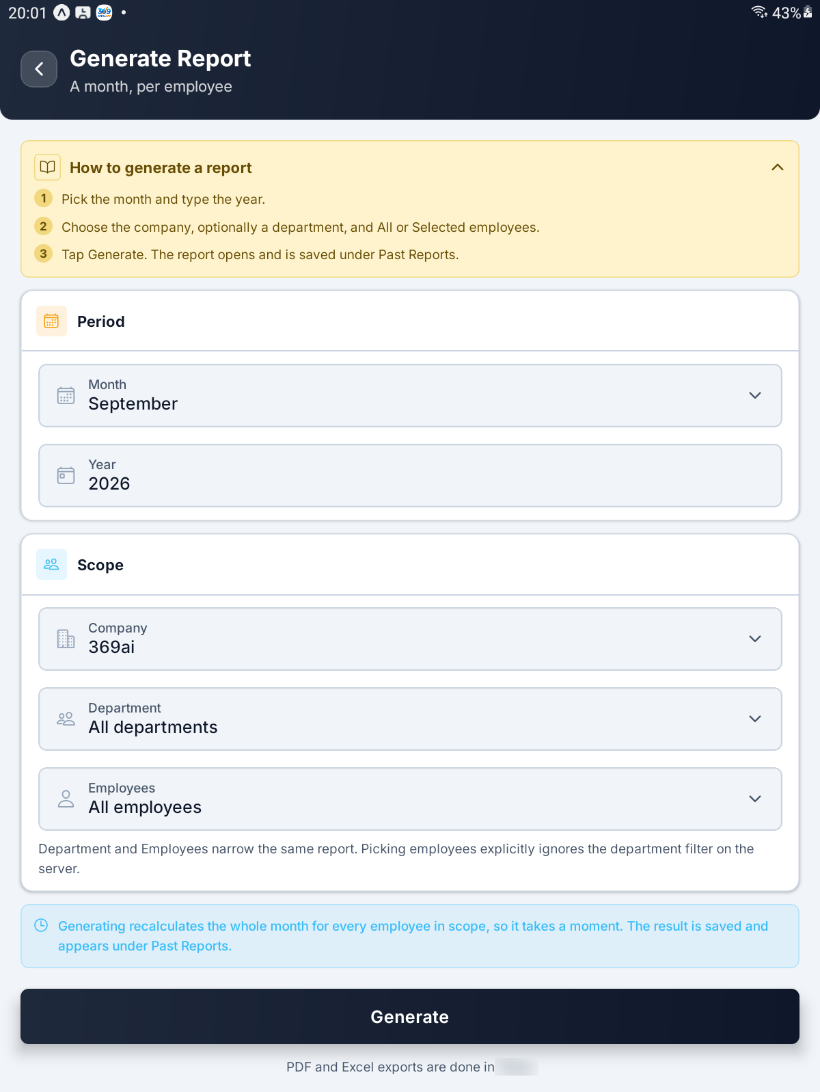
Generate Report — Period, Scope and the Generate button

Step 38 Read and Recalculate a Report
The report opens on Grand totals: Period, Wage, Leave deduction, Total deduction and Final amount, with a chip counting the employees.
Under PER EMPLOYEE, each row shows present over working days — for example 0/26 days — then any late, unpaid and comp-off days, the final amount, and the deduction in red.
Tap an employee for their day-by-day lines. Each card is one line the report captured: a day, a late record or a leave, with empty values left out.
Recalculate refreshes the figures from current attendance; you will see Report recalculated.
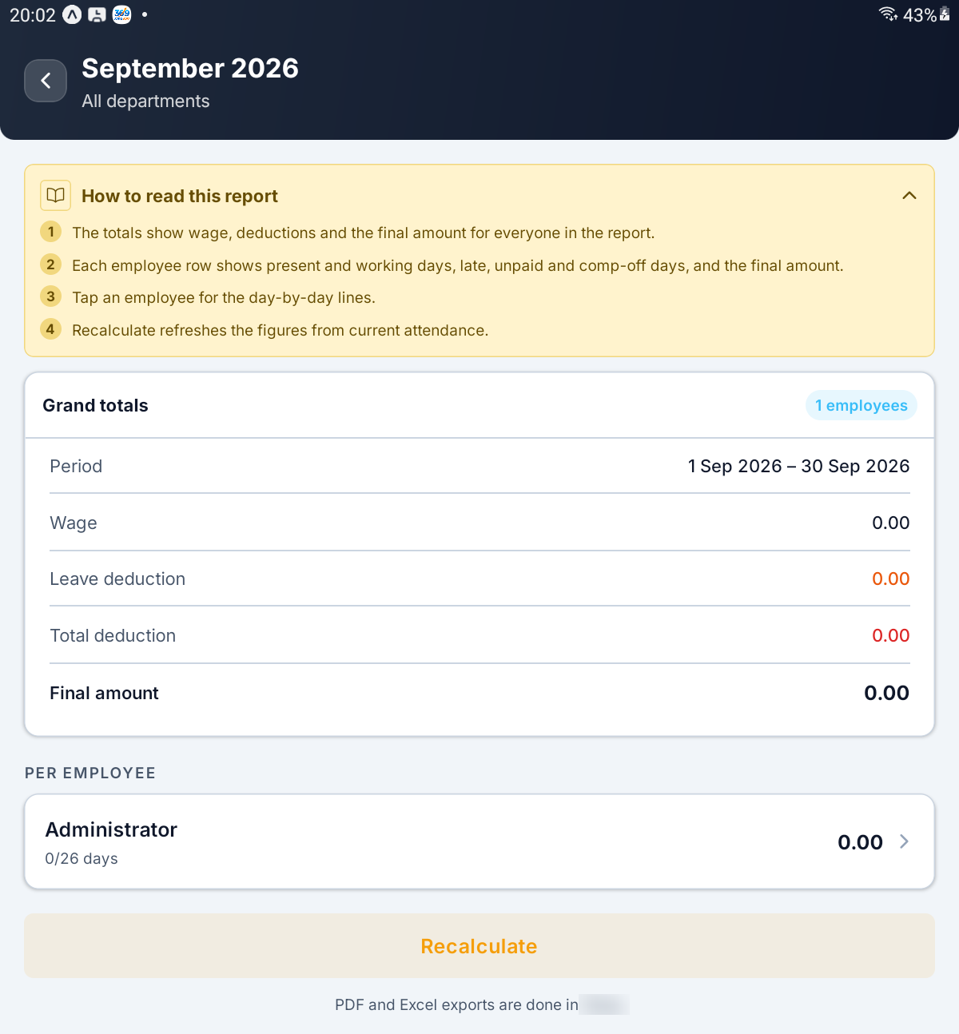
A report — Grand totals, one employee row and Recalculate

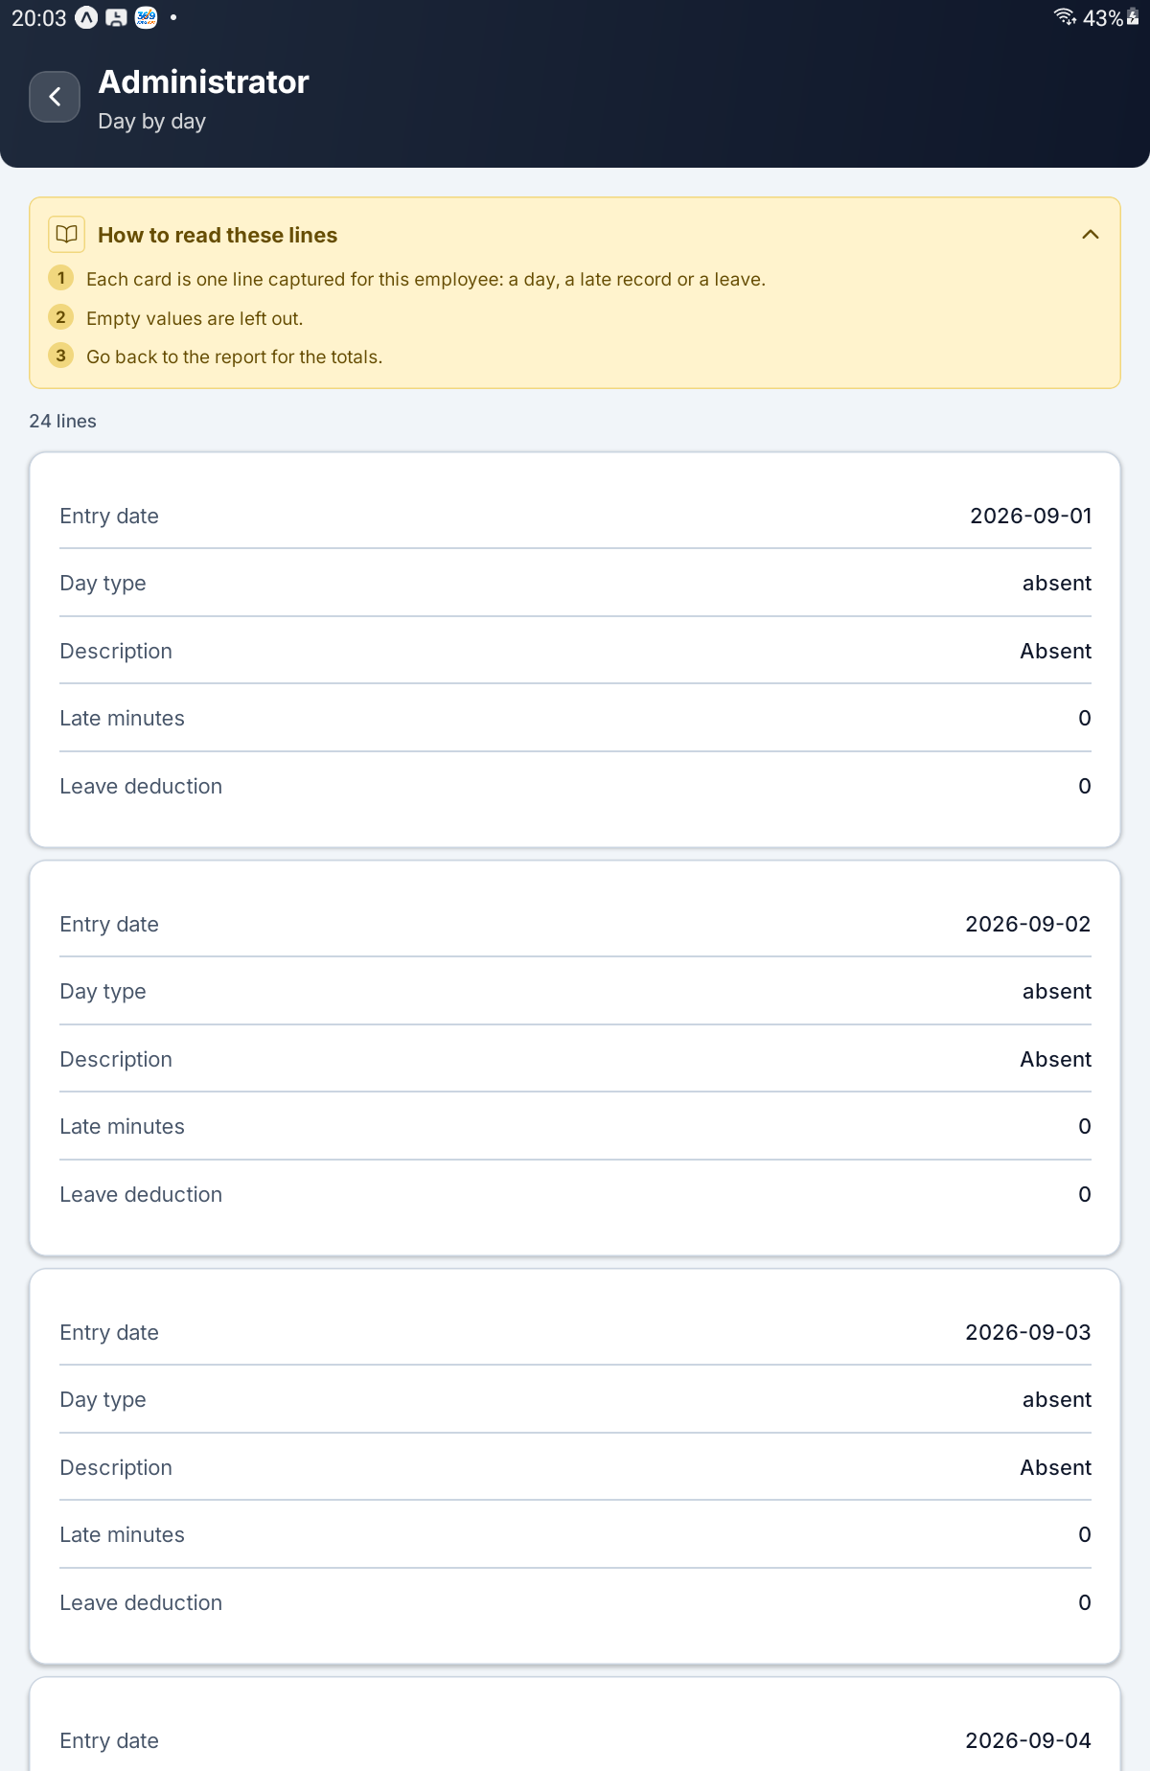
One employee's day-by-day lines

Step 39 Open a Past Report
Tap Past Reports (What was generated before). Each row is one saved report, with its month, department and company, and its final amount. Tap one to open it, and Recalculate to bring it up to date. An empty list says No reports yet.
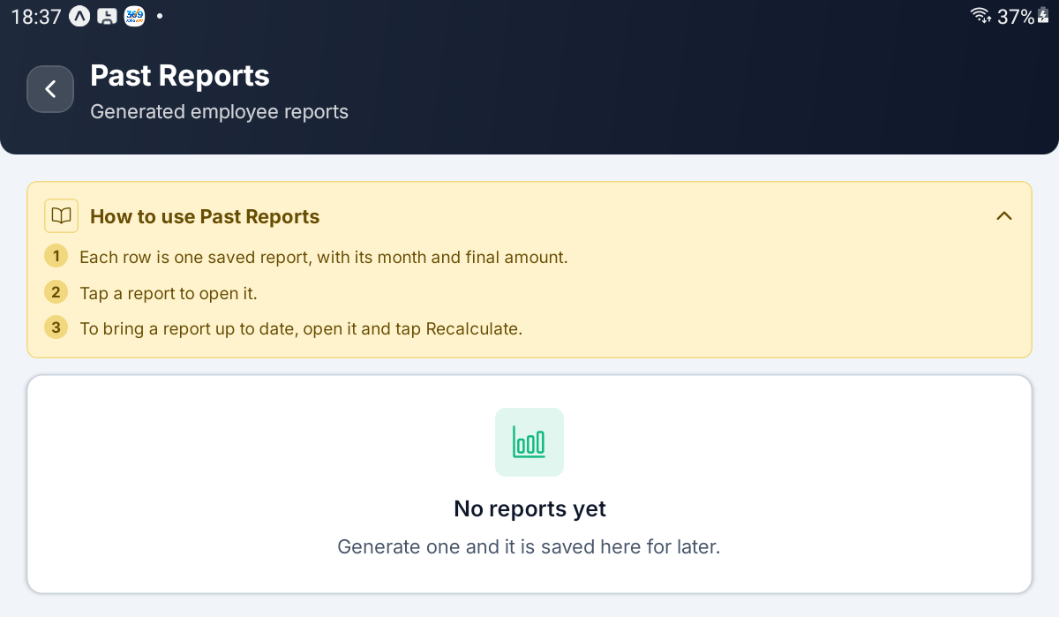
Past Reports before any report has been generated

QUICK REFERENCE

Where Things Live
To do this | Go here
See who is missing today | Config → Absent Today
See every late check-in | Config → Late Records
See how each day was graded | Config → Day Status
Rank late days for a month | Config → Monthly Summary → Generate
Approve or reject leave | Config → All Leave Requests
Decide a leave cancellation | All Leave Requests → Cancellation
See what leave was granted | Config → Approved Leaves Report
Add a comp-off credit by hand | Compensatory Off → Add a credit
See anyone's leave balance | Config → Leave Balances
Change paid days or comp-off expiry | Config → Leave Policy
Approve or reject work from home | Config → All WFH Requests
Change office hours or grace | Office Hours & Working Days → tap a card
Switch on automatic Absent | Office Hours & Working Days → Late window ends
Add a public holiday | Public Holidays → Add a holiday
Auto-approve waiting requests | Config → Auto-Approval
Choose which employee details are kept | Config → Field Settings
Change the pay structure | Config → Salary Components
Run the month's payroll | Payroll Runs → New payroll run
Report on a month | Config → Generate Report

Who Can Do What
Task | Employee | HR | Admin
See the Config tab | No | No — gets the HR tab | Yes
See who is absent today | No | Yes, on the HR tab | Yes
Approve or reject leave | No | Yes | Yes
Decide a leave cancellation | No | Yes | Yes
Approve or reject work from home | No | Yes | Yes
Late Records, Day Status, Monthly Summary | No | No | Yes
Comp-off credits and leave balances | No | No | Yes
Leave Policy and Auto-Approval | No | No | Yes
Office hours, ladder and holidays | No | No | Yes
Field settings, salary components, statutory IDs | No | No | Yes
Payroll runs and reports | No | No | Yes

An administrator sees each section only when their login carries the right behind it; a missing section is a missing right, not a fault.

Things to Remember
▪ Being late costs nothing. A Half Day is the only pay cut, an Absent day is simply not earned, and days off and holidays are always paid.
▪ The ladder ships switched off. Until you set Late window ends, nobody is ever stamped Absent.
▪ Holidays raise the daily rate. A counted holiday leaves the working-day count the monthly wage is divided by; removing one lowers it.
▪ New rule sets are made on the web console. The app edits the office-hours rules that already exist.
▪ Saving the rules re-grades three months. Old records follow the new rules.
▪ Policy changes apply from now on. Leave already decided keeps its paid and unpaid split.
▪ Paid leave does not carry forward. Comp off can, up to the cap you set.
▪ A wait of zero switches auto-approval off, whatever the switch says.
▪ Earnings must match the Monthly Wage, or the payroll run cannot be confirmed.
▪ Mark paid is final. A paid run can never be reopened.
▪ Cancelling approved leave stops at payroll. It is refused once that month's run is confirmed or paid.
▪ Payslip PDFs and report exports come from the web console, not the app.
▪ My details never shows salary, bank or statutory details, whatever Field Settings says.
Set the rules once, clear the red badges every morning, and close each month's payroll. Everything else in this guide supports those three.

— End of Guide —
Alphalize Technologies | 369 Attendance Administrator Guide

